MODIFICATIONS – ICR TRAVEL BOOKING SYSTEM
1 - CUSTOMER NAMES & AGES ON BOOKING FORM & WHEN SENDING FAX TO HOTELS
- On our booking form, just below where we enter the number of adults, children 6-12- or children 0-6, we want text boxes to appear(ajax) for us to enter the names of all the passengers along with their ages.
Done – All GOOD
- First box will be the lead passenger and will auto fill the name from the main customer name on booking form above. The rest of the boxes will have drop down suffix of mr. Mrs. Ms. Jr. With a passanger name field and an age box to enter manually.
Done – ALL GOOD
- When sending “hotel confirmation fax&mail” to the hotel, this information will be entered below the booking details on “one line”. i.e
Mr.John Smith (64) – Mrs.Karen Smith (60) – Ms.Julie Smith (9) – Jr.Dodd Smith (2)
Done – NOT ABLE TO TEST SINCE THE BOOKINGS ADDED AND IN PENDING FOR 2012 DO NOT SHOW AT MANAGE HOTEL CONFIRMATIONS DONE DONE
- These Fields will not be mandatory.Done - ALL GOOD
- The number of fields will be equal to the total of guests i.e 2 adults, 1 child, 2 babies = 5 lines of boxes.Done - ALL GOOD
TRANSFER SERVICE PROVIDERS & TRACKING NUMBERS

- We now have multiple providers of airport transfer services therefore we will need additional fields to distinguish which customer will be travelleing with which transfer company.
- On our booking form, after TRANSFERS, we need a drop down of transfer companies IF other than No transfers, pending decision or other is picked from the list then a company must be selected.
- ICR
- ResortHoppa
- A2B
- ICR-AYTUR
DoneALL GOOD
We should be able to add/edit transfer companies from user settings.You can edit the companies from under Daily Payments>Transfer Companies listALL GOOD
2 – Next to chosen transfer company, a new field (text box) should be placed to enter Tracking Number : filling it is not mandatory to submit form because we will only use these numbers with external companies. But if its entered, it will show on our lists as in the example below with an edit link. The edit link is there so we can add the tracking number at a later time. (Edit option here should work as it does on invoices page which i think is ajax)
DoneALL GOOD
Example:

1 - 250 of 899 [ 1 2 3 4 ] Next >> | Send Mail | Send Sms to all customers.

 | Ref no. | Name | Arr. Date | Dep. Date | Arr. Time | Dep.  Time | Hotel/ Apart |  | Transfer | Trsf Co. & Track No: | Flight No. | Nts | #Rms | #Pax | Board | Airport | Dep. Paid | Dep. | Bal. | Action
 | ICMSC5971 | Phil Biggs | 16/6/2012 | 30/6/2012 | 02:50 | 03:50 | Rhodes |  | RETURN | Resort Hoppa  edit | TOM248 TOM249 | 14 | 3 | 6 | SC | DLM | yes | 120 | 0 | Edit|Del |Cancel |Mail | Sms
 | ICMSC5998 | Alan Storey | 7/5/2012 | 29/5/2012 | 13:20 | 01:00 | Melita |  | RETURN | ICR  edit | TCX6518 | 22 | 1 | 2 | SC | DLM | yes | 150 | 0 | Edit|Del |Cancel |Mail | Sms

3) ON Manage Bookings Page and Hotel Confirmations page as well as Hotel payments Page, we must have the options to filter by transfer type and transfer provider company and to search by tracking no
DoneALL GOOD

HOTEL PROVIDERS & LOCATOR NUMBERS
ON THE BOOKING FORM - If a given HOTEL chosen from our hotel list and the Hotel Provider field in hotel detailspage is not equal to ICR Travel then a text field value – “Locator Number” to appear below (ajax) asking for a LOCATOR NUMBER from us. Entry must be mandatory when this rule applies. Locator Number when entered should show for the booking on all the booking listsDone – Lets please change the Locator number font color to red.DONE
On All Booking lists – Manage Bookings, Manage Hotel Confirmations, Manage Payments
The list should have this new field – Locator no: (see example)

- BOOKING FORM - Calendar to pick dates, please change it to the one you used for price match form.DoneALL GOOD
- BOOKING DATE” FIELD TO APPEAR ON MANAGE BOOKING LIST & MANAGE HOTEL CONFIRMATIONS & MANAGE HOTEL PAYMENTS LIST.
DoneNeed to ask a question. Is this date the one saved automatically at the time the booking is added >?YESALL GOOD
This should be the first field to the left.
So with the Transfers and Hotel Providers adjustments, our new lists should show as follows:

Example:
1 - 250 of 899 [ 1 2 3 4 ] Next >> | Send Mail | Send Sms to all customers.

Booking Date | Ref no. | Name | Arr. Date | Dep. Date | Arr. Time | Dep.  Time | Hotel/ Apart | Locator No: | Transfer | Trsf Co. & Track No: | Flight No. | Nts | #Rms | #Pax | Board | Airport | Dep. Paid | Dep. | Bal. | Action
NEW | ICMSC5971 | Phil Biggs | 16/6/2012 | 30/6/2012 | 02:50 | 03:50 | Rhodes | NEW | RETURN | edit | TOM248 TOM249 | 14 | 3 | 6 | SC | DLM | yes | 120 | 0 | Edit|Del |Cancel |Mail | Sms
NEW | ICMSC5998 | Alan Storey | 7/5/2012 | 29/5/2012 | 13:20 | 01:00 | Melita | NEW | RETURN | edit | TCX6518 | 22 | 1 | 2 | SC | DLM | yes | 150 | 0 | Edit|Del |Cancel |Mail | Sms

- We should be able to search a booking by locator number.DoneNOT DONE – Tracking no is done but not search by Locator Number DONE
NOTES: Field widths need expanding please because the tracking numbers and locator numbers should be on a single line but because the fields are too narrow, they collapse to next line making the view of bookings at a glance very hard.

- GLITCHES & EXISTING PROBLEMS THAT NEED AMMENDING:

- BOOKING RECORD DATE FORMAT WHEN SENDING FAX CONFIRMATION TO HOTEL NEEDS CHANGING FROM NUMERIC FORMAT TO DATE FORMAT.
Done – AGAIN NOT ABLE TO CHECK SINCE MANAGE BOOKING CONFIRMATIONS LINK COMES WITH 0 BOOKINGS DONE

- SENDING SMS TO FILTERED RESULTS ONLY – NEED KNOW HOW
SENDING MAIL TO FILTERED CUSTOMERS ONLY – NEED KNOW HOW
Maybe its better if we have a link saying “send sms/ send mail to filtered results only” option on the page to eliminate confusions.

NOT DONENOT DONE

- CUSTOMER CONTROL PANEL : NEED TO CHANGE TEXT LINKS TO BUTTONS – ALL
- please make the customer page where bookings are listed with edit-mail – print etc options into buttons instead of text links to make it look more fresh and upto date.Done - MISSING
NOTES:
- - Forms awaiting for completion Needs Removing from Customer log-in Page (we no longer use this)DONE
- - Also, can we please have ALL the links in a button format including the above links showing for pending bookings and confirmed bookings etc. DONE
- - Please check out the image below: Can we have £ sign before the price information i.e £500 £200 £300 for the example below. DONE
- - Ref No, Hotel, Arrival Date etc headings, can we have them changed slightly to show an upgrade i.e imgNOT DONE

- - Now that we have the options list as buttons (nice!), the list of buttons obviously made the table too high, can we have this page a little more organized and optimised please, revamped a little please... DONE
- -6- I got this error when I clicked view / print buttons Invalid condition where cust_id= on table customerNOT DONE

- 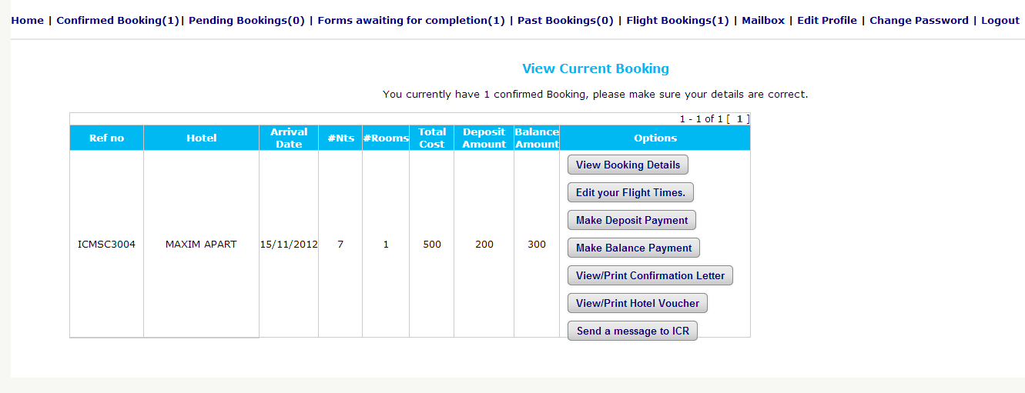

- Customers log in to change their time of arrival and departure etc, but once they submit, the booking either disappears or becomes a booking with no dates absolutely. I am not sure if we can replicate the problem but this did happen just few days ago so there is a problem there. Maybe its the next day arrival/departure ticks. So please look into it and let us know if you find the problem and as to if its rectified.
Cannot find this one -OK

- HOTEL CONFIRMATION FAX-MAIL: CONFIRMED AND CAN NOT CONFIRM LINKS TO CHANGE FROM TEXT TO BUTTONS. IF NOT CONFIRMED – A WINDOW TO ENTER REASON FOR NO CONFIRMATION AND SUBMIT.
Hotels usually confirm or not confirm by mail as we set it up but can we change these links to visual green and red buttons to make it look more professional. Also, if they choose not to confirm, they can then enter it in a new text window asking why, and so we can receive the reasoning with it.
Done – NOT ABLE TO CHECK BECAUSE AGAIN, I AM NOT ABLE TO FAX/EMAIL TO HOTEL AS I DONT SEE ANY BOOKINGS TO BE SEND FOR CONFIRMATION.
ADDITION
- – I did forget to add one thing to this project and that was the “Room Type” section to show the room type for each chosen number of rooms.
A) This new field will also show in all booking lists next to the “number of rooms” field
B) On Booking form, once the number of rooms entered, it will work just like the passanger details and a room type box(s) will appear below respective to the amount entered in number of rooms field, to pick from a drop down list. The list will be editable for the room types section to be added.
On booking lists, manage payments and manage confirmations lists etc, to save space, we can show all types of rooms for a given booking by adding 1X or 2X, 3X etc before them depending on the total number of rooms chosen for a given booking and still show them in the same cell by having this field wide enough.
i.e
1X Standard Double
2X Twin
1X Attic Apartment.

For such result to show as above, we would have needed to enter 4 rooms’ details for that given booking and chosen Twin twice from the drop down options. DONE

