Bugs:
1. Formatting on Form Page: I just checked this out Gaurav, these are still problems
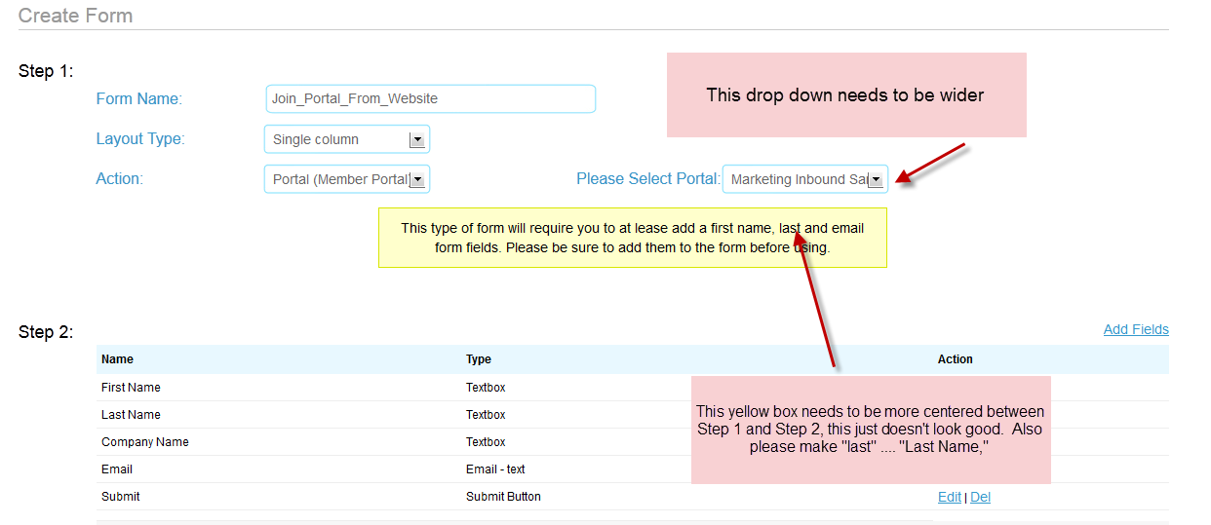

2. No Top Menu Bar: When you select no top menu bar as I did on this page, it still shows up. ALSO, there’s currently no selection for a No Anything page on open portals, there should be.
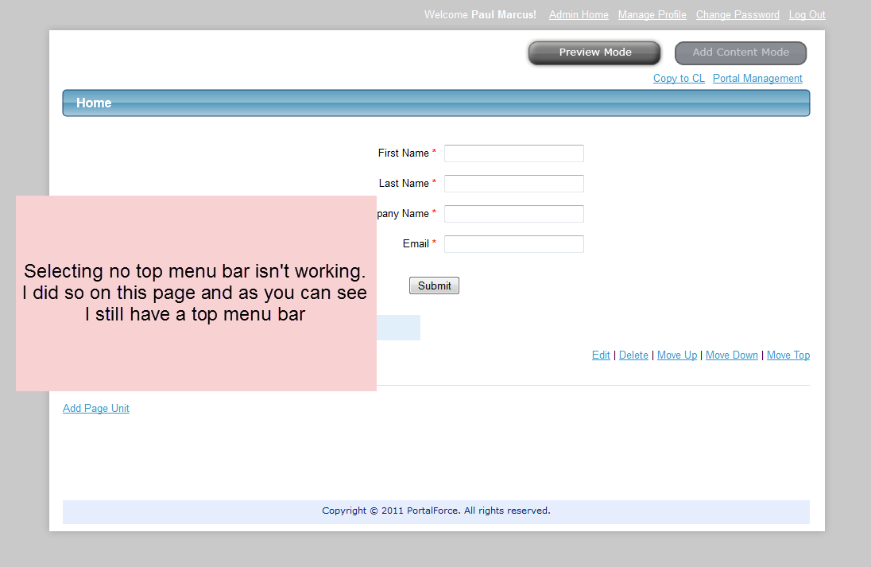
3. Delete all prospects not on a portal not working as you know
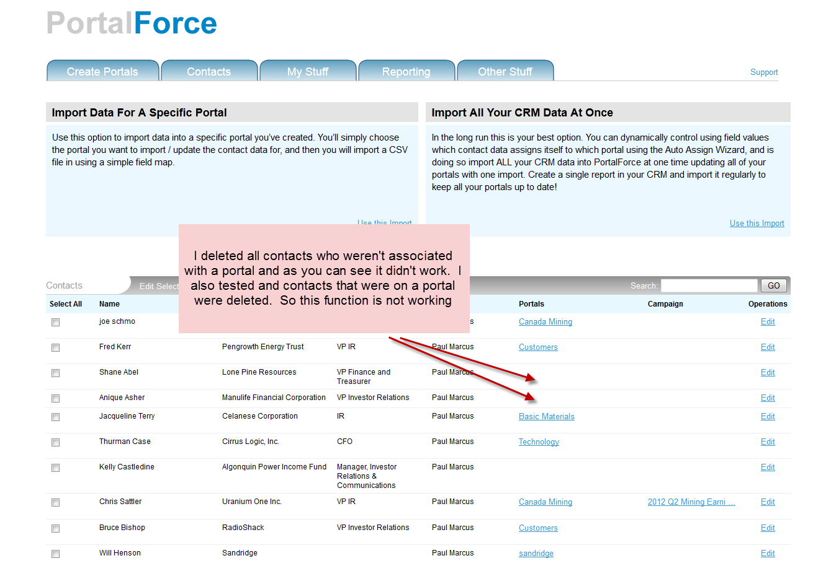

4.

New Specs

4. Some changes to make create/edit portal page easier, just see this shot
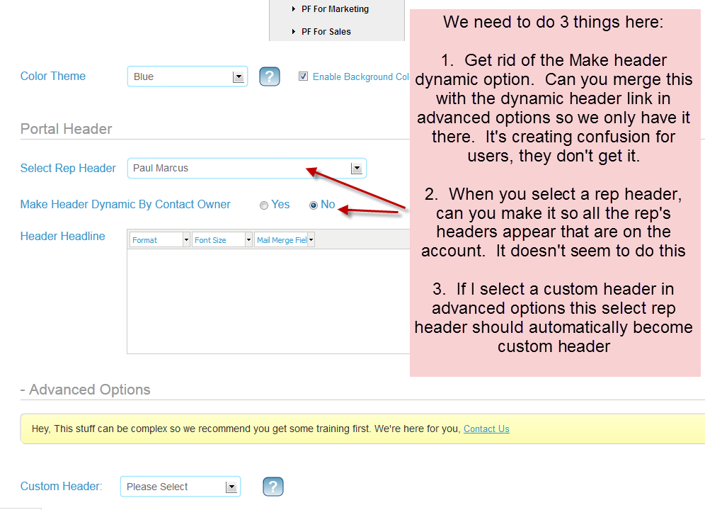

5. More changes to this page, see two shots below
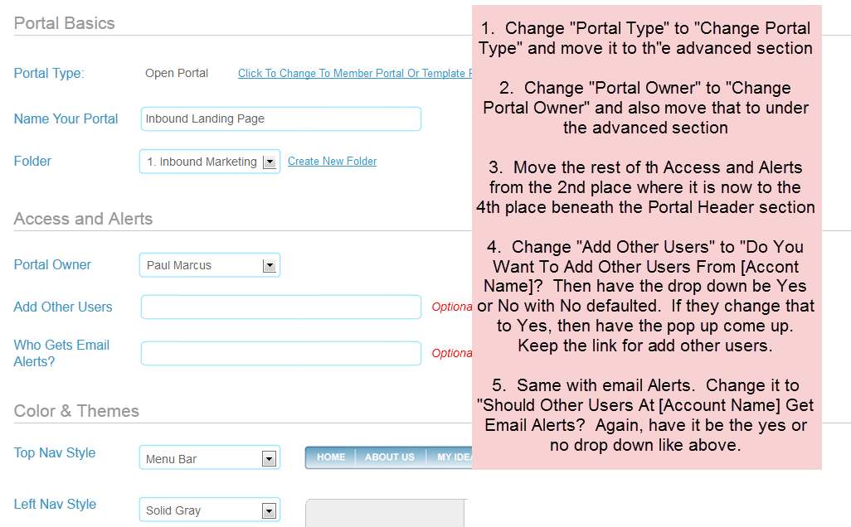

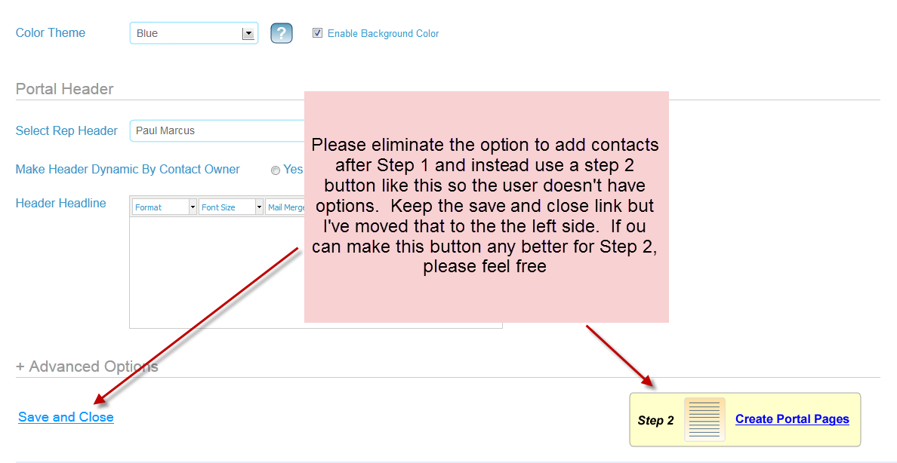

6. Portal Management: In my most recent focus groups users found the new create portal process much more intuitive, but then got stuck on portal management. They just didn’t know what to click on. A couple things came out of it:
a. Users want to build the portal BEFORE worrying about importing data.
b. The name Portal Management didn’t make any sense to them, so as you’ll see below I’m changing it to “Edit Portal” which is the best thing the group came up with
c. There needs to be a more obvious and sequential process that someone follows, and it needs to be obvious. That is: create portal, build pages, add contacts, create campaigns
In this first screen shot you’ll see the changes I want to start to achieve this:
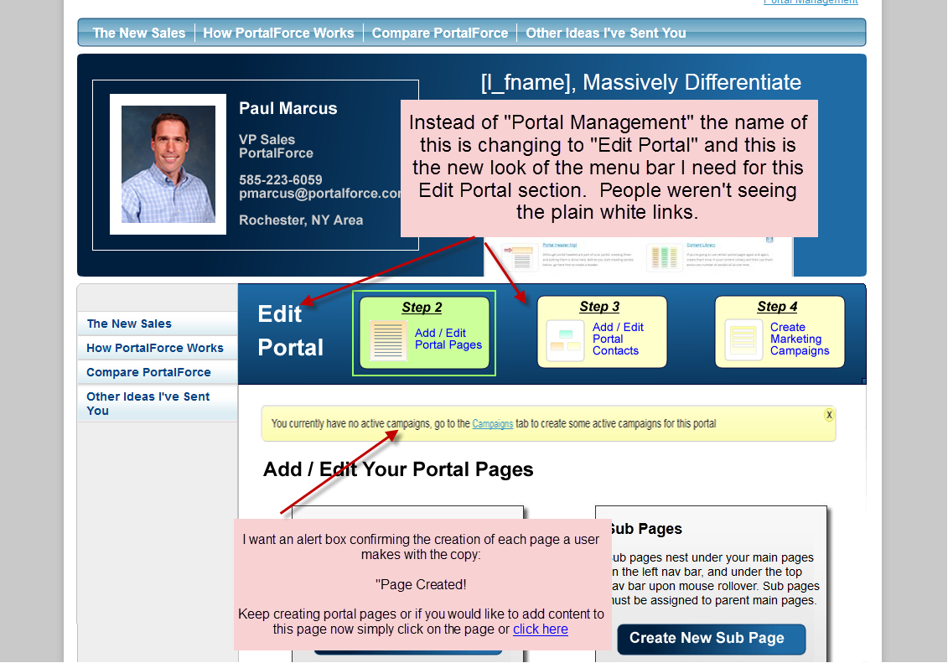

7. As you’re going to see here with these changes, I’m going to buttons instead of links. In the focus group users weren’t finding the links, they didn’t jump out enough. So I’m eliminating unnecessary ones and making the ones I leave more obvious, see this shot below:
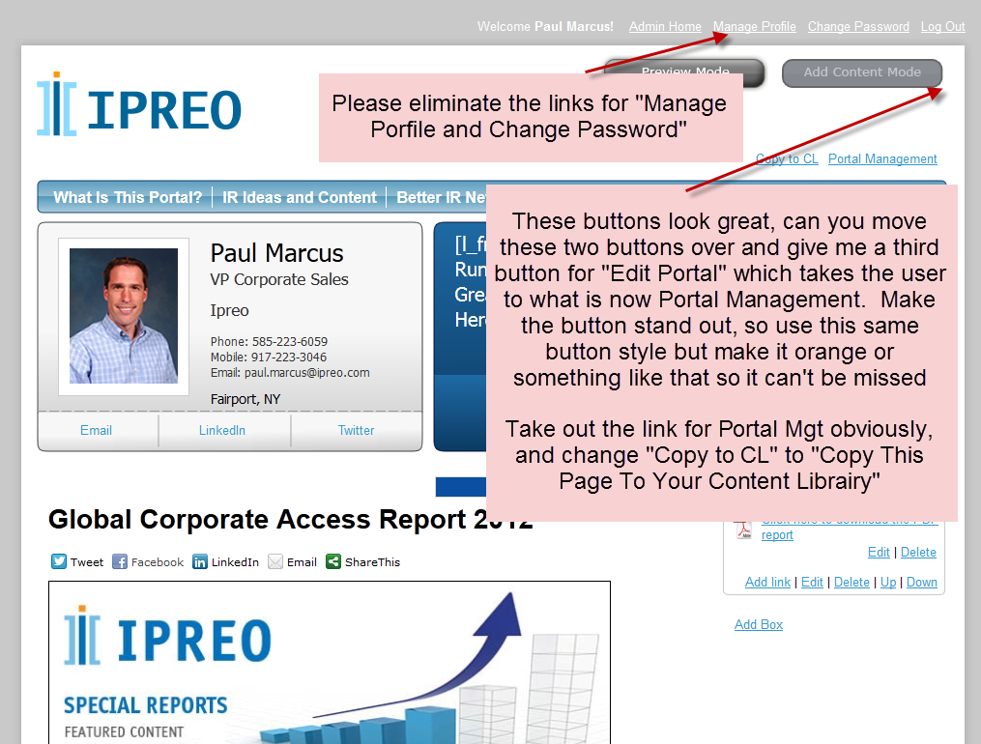

8. These updates are pretty obvious:
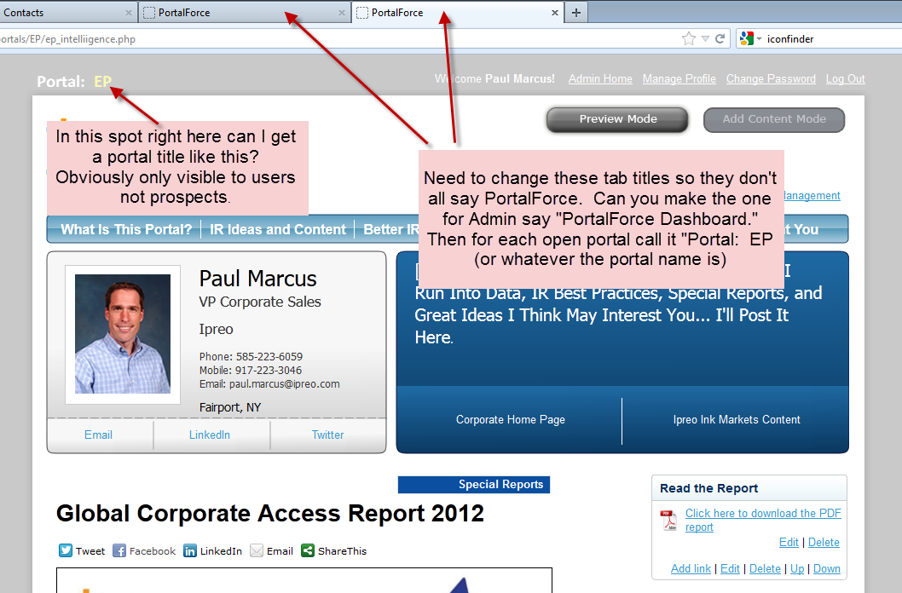

9. Again, with the button thing to make things jump out more. Use the same style button for all of these new buttons. I really liked the style you built for preview mode…
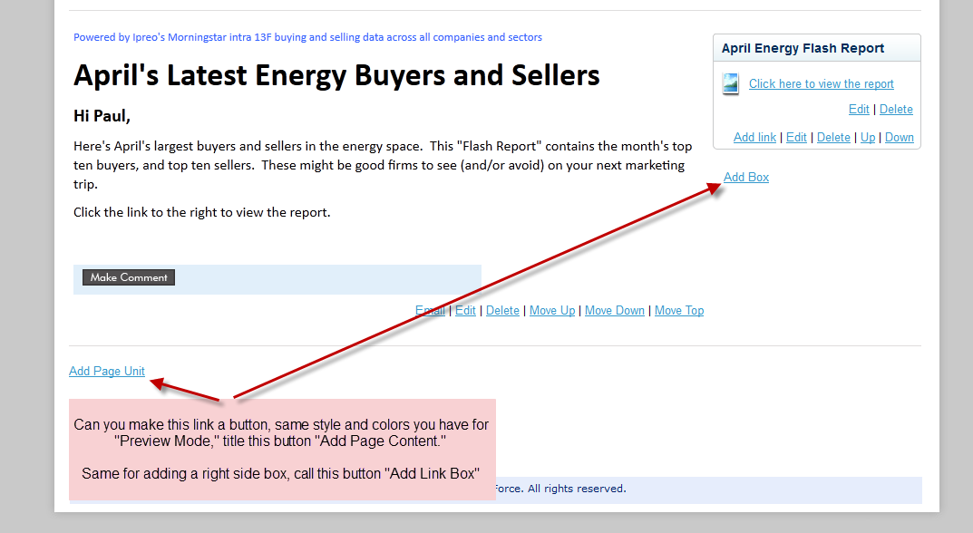

9. We need to change the way we show the options for importing contacts into a portal. So instead of just listing the 4 options out I’ve decided to use a button approach. Same functions, just a change in interface design. In the screenshot I’ve expanded the auto-assign wizard but I want the default for that not to be viewed like our advanced options in the portal creation process. People I showed it to were confused by it so I want it to be an advanced option that people need to expand to use so it doesn’t confused users who aren’t advanced.
With this button approach you’ll need to figure out how the user enters the data. That is when they click on a button do the fields appear beneath the buttons or will you use a pop up? I’ll leave this up to you and whatever you consider best practices today. Also, you can see that I have the selected button a different color so the user knows which page they are on. Can you also have these change on mouse rollover.
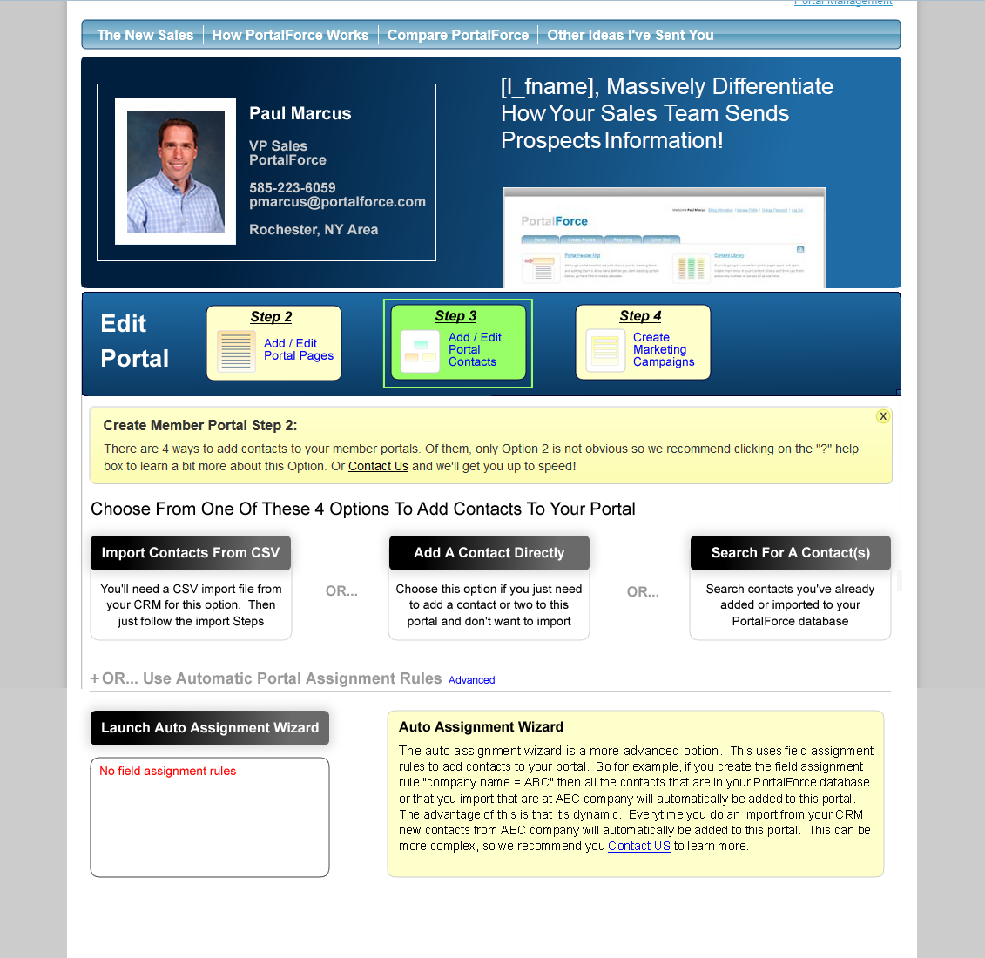
10. Right now our current campaign creation is all over the place. First you have to create templates, then campaigns which confuses people. The click on create campaign only to find they can’t create a campaign they first have to go back and create templates, so I did not design that with much forethought. What I’m trying to do here is make that process workflow more intuitive.
So as you can see on the screenshot below when a person clicks on Create Campaigns in the Edit Portal (Portal Mgt) section they should go now to what we have as Active Campaigns. If they don’t have any active campaigns then the three buttons you see at the bottom of this screen shot to create a new campaign, etc… should be moved up and beneath them should be the yellow alert box we have now that says they need to create a campaign first. If they do have active campaigns then those should be shows below like this screen shot with the 2 yellow boxes telling them how many contacts they currently have in active campaigns, and how many they have available to add to their active campaign. There’s also the button there to add contacts to their active campaign and you’ll again have to decide if best practice is to have the fields appear below the button our use a pop up.
Notice the buttons as well to enter the campaign execution page, jumps out more than the link which people were missing. You can leave the link there as well I would think.
There are separate links at the top to view your existing campaigns, and for the three templates pages. I think however you should make the link to view existing campaigns a button like those below so it stands apart as more important than the template pages.
Regarding the three buttons on the buttons I have them described below except the send one time email which should just take them to the compose page.
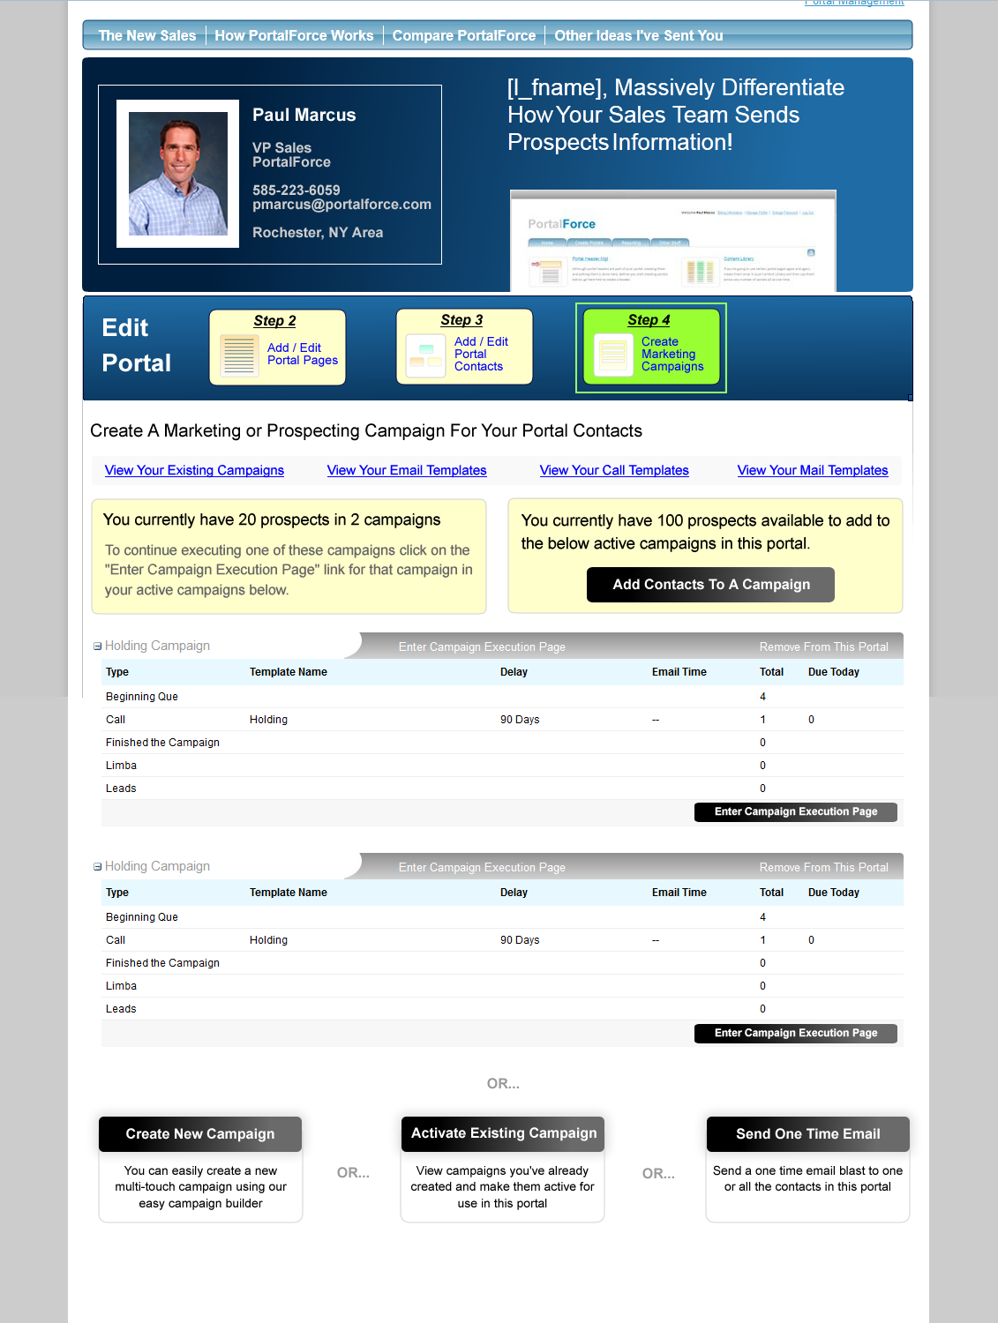

11. This is a screenshot of the current Campaigns page. So if they click on the button Activate Existing Campaign they go here. The screenshot pretty much says it all, let me know if you have any questions
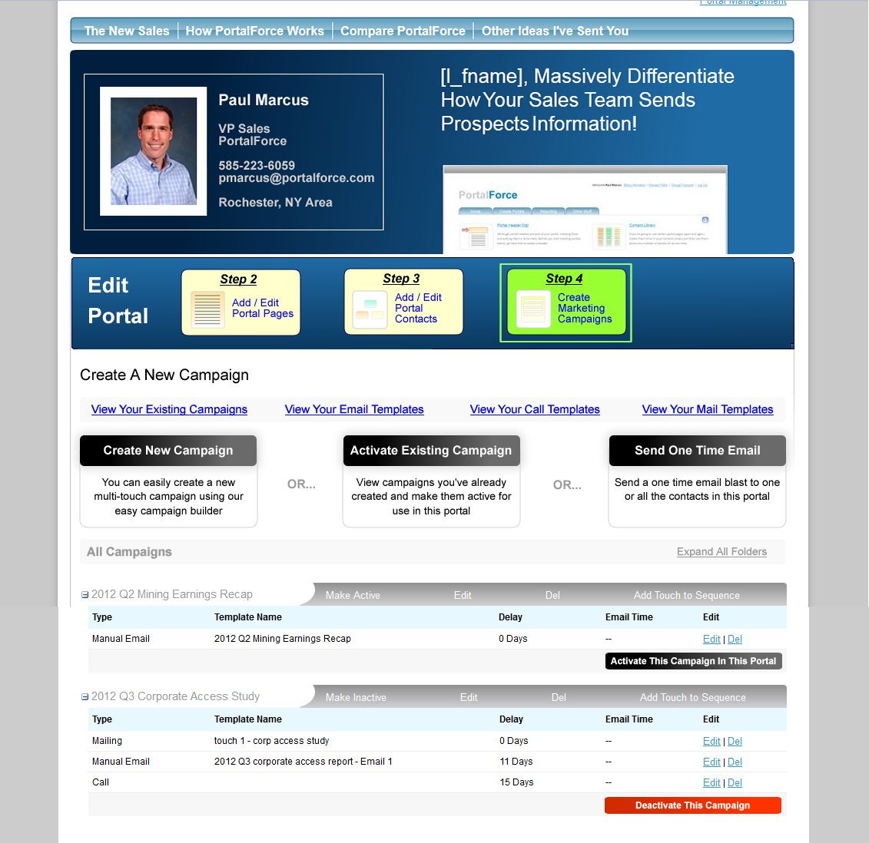

12. The Create New Campaign button takes you to this screenshot. Instead of the user having to separately create templates from campaigns I want them to be able to do it all in one step. So be able to:
a. Create the campaign
b. Create the touches
c. Create the templates
All in one process.
Step 1 is obvious, they name their new campaign.
Step 2 is where we combine all of the above. So it starts out with the first touch where they can either use an existing template or create a new one. In this screenshot they are creating a new one. If they do use an existing template then when they choose the template it should still show all the template fields so they can make changes to that template if they want to. It should be noted than any templates they create or change in this process should be saved to the templates section.
After they are done changing or building their new template, they then edit the touch settings of days delay, etc… When they do change the days delay it should be reflected in the red text at the top of that touch which shows the days delayed as you can see in the screen shot.
Then they have 3 buttons they can choose from:
- Add another touch: this should add another touch segment right below this one like we do in our auto assign wizard. They can add as many touches as they want and build the entire campaign and all its templates right on this one page.
- Save and make active for this portal: this obviously just saves the campaign and makes it active
- Save and activate later: saves the campaign but doesn’t activate it.
Whichever button they click should then refresh the screen and bring them back to either their active campaigns page if they saved it and made it active or their campaigns page if they chose to activate it later, either way they should see the end location of their new campaign.
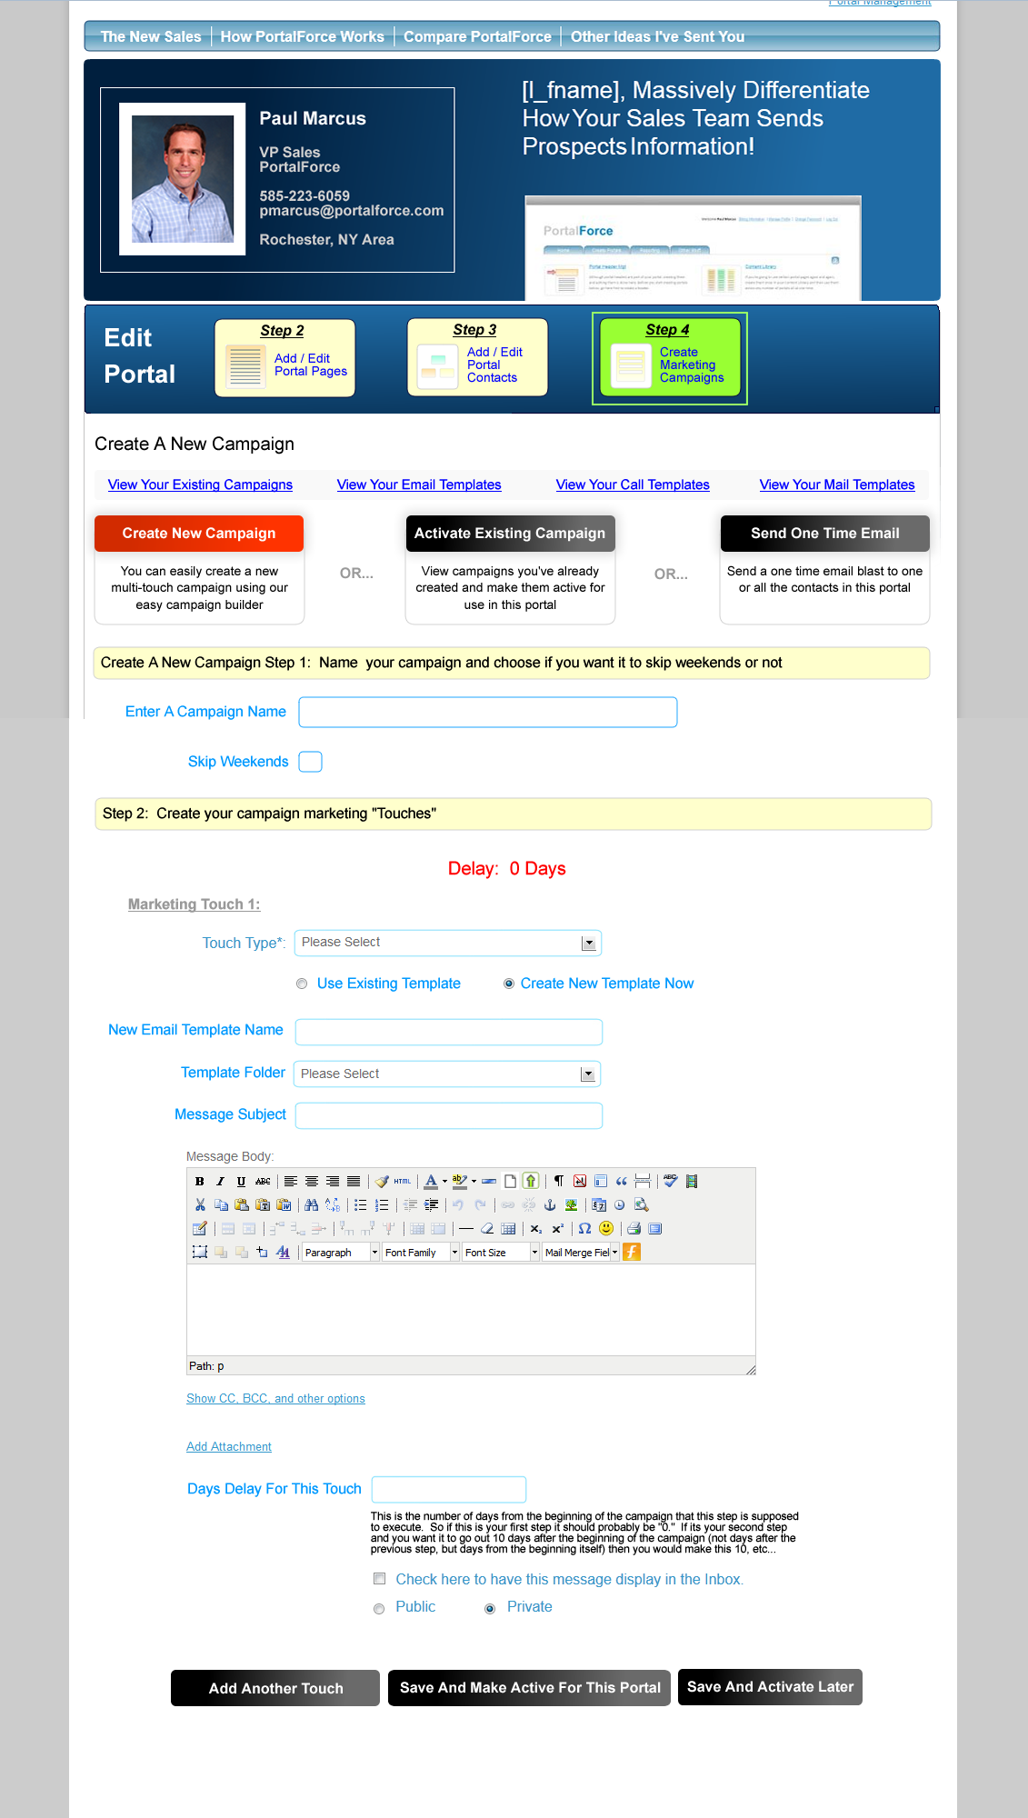
13. The final question is what should happen to the messaging page if all of these campaign changes are being made to Edit Portal. I think the Messaging page should just go back to:
1. Inbox
2. Send An Email (instead of Compose)
And let’s keep all of the campaigns in Edit Portal. They of course should still see all emails sent from campaigns in the inbox, but let’s just have it be one place where campaigns are put together and templates changed, etc…

