1.
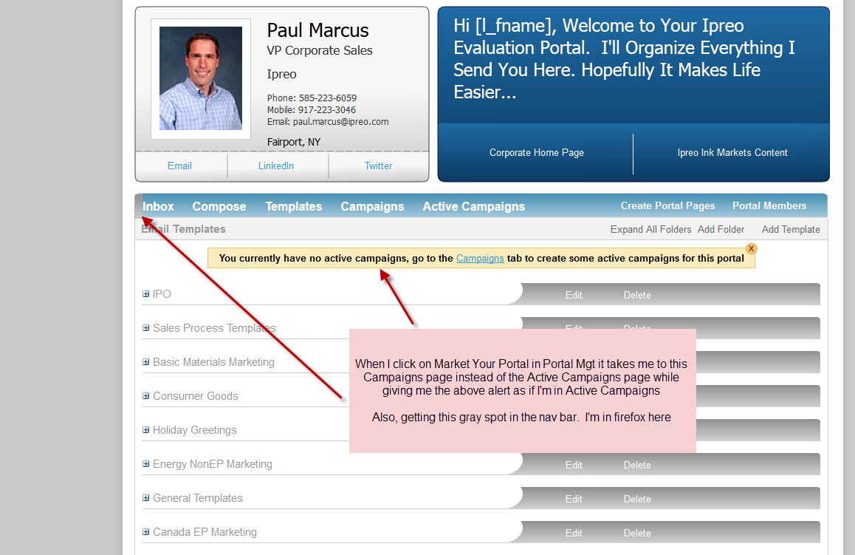
Also on the above screen shot. The yellow alert only pops up if I click to it from the Portal Mgt section, make this yellow alert appear in the active campaigns page any time there’s no active campains.
2.
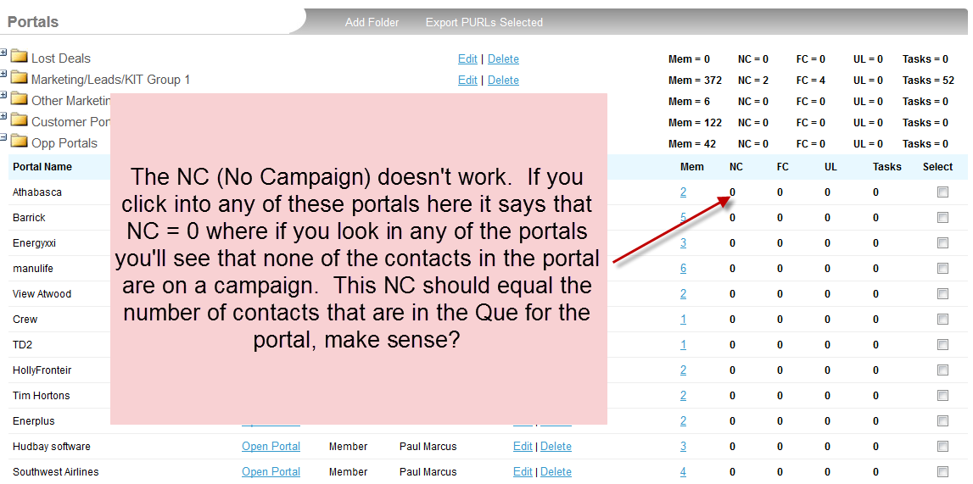
3. When you create open portals, you shouldn’t see the link “Save and Add Contacts”

4.
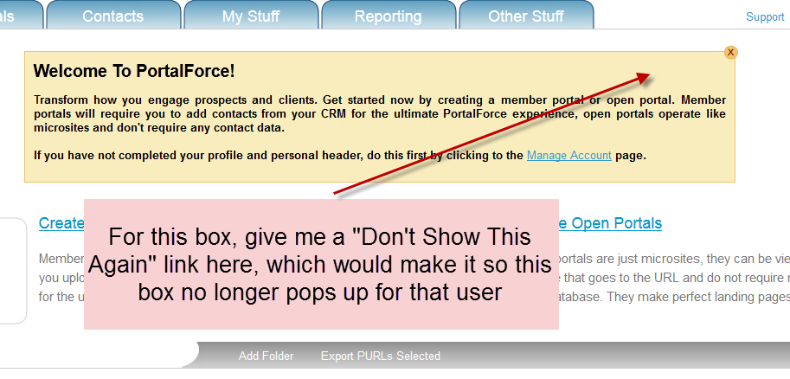

5. One more thing. On the Create Portals page can you change the default from the portals being closed to the portals being open. Then give me the link in the bar to Open All and Close all. Thx.

