Tablets Design
- Need to align 20px right
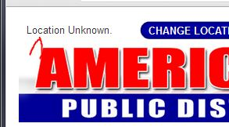
- IN internet explore
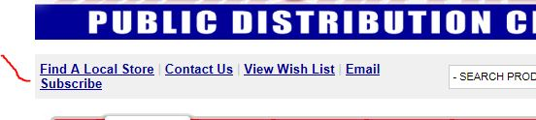

- Search text box should filled “SEARCH PRODUCT “after clicked anywhere page


- Should be align
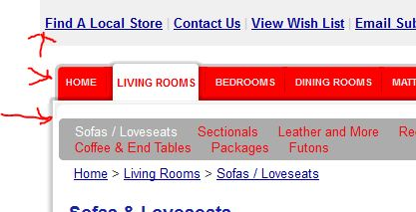
- Need to correct validation
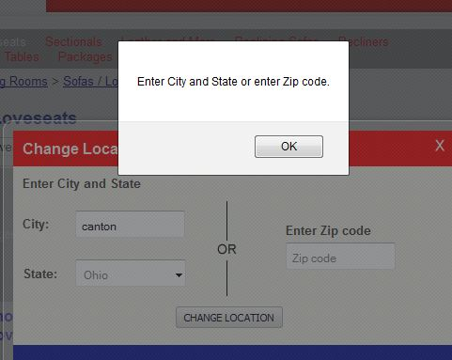

- Should be align
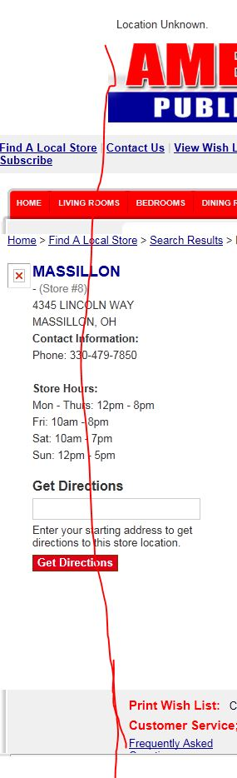
- Spacing between map and text
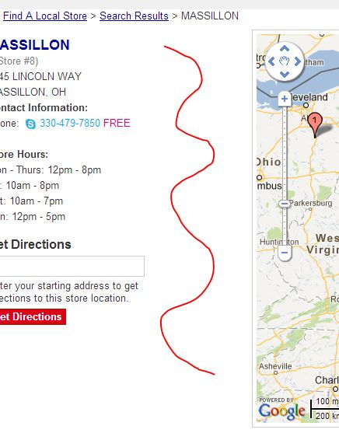

- Removed footer link in every pages
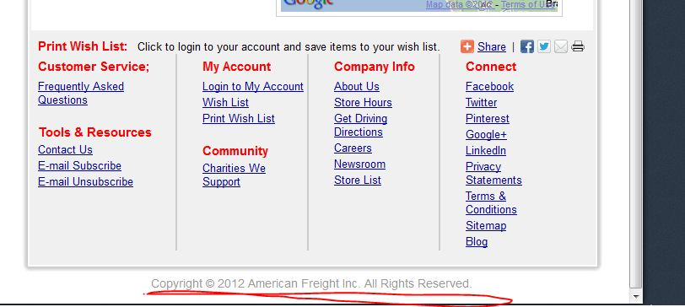
- Should be align right
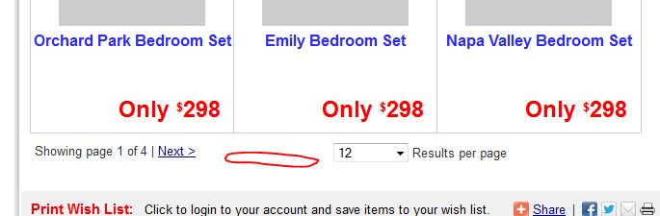

- Internet explore
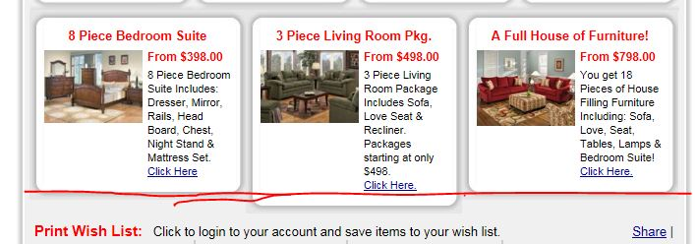

- No wrap
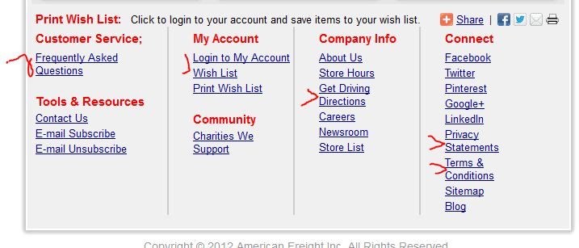12. Spacing and alignment
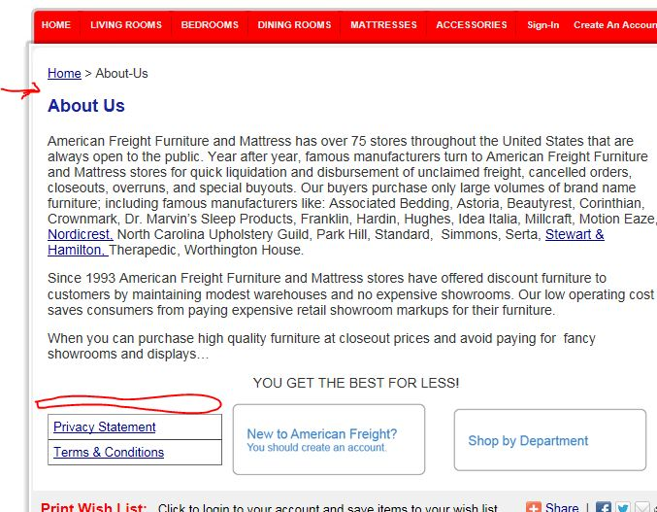

- Page formatting and removed background color. also in terms and conditions page
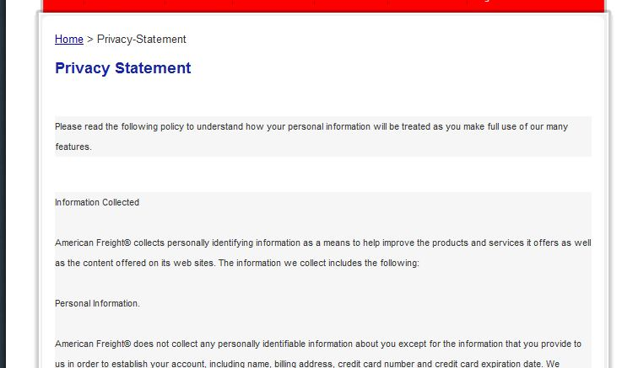

14. Change link shop by Department
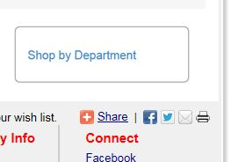

15. Need spacing Faq page
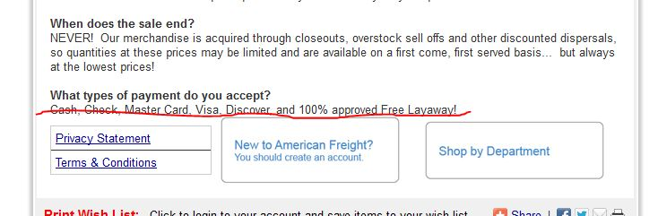

16. Removed scrolling from
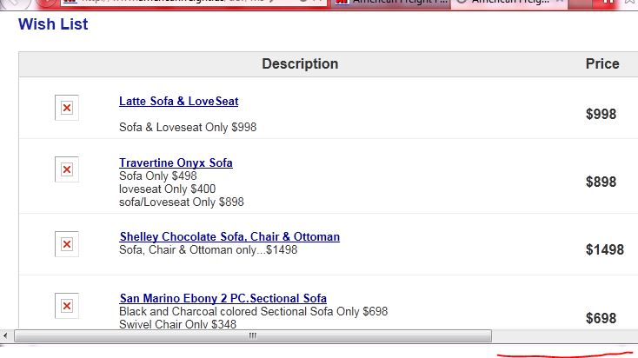

17. When we open these pages. Getting scrolling and need to removed extra footer contents
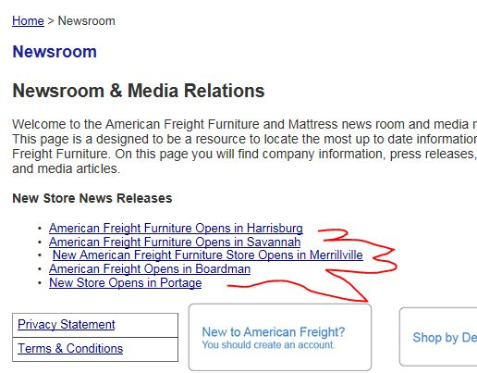
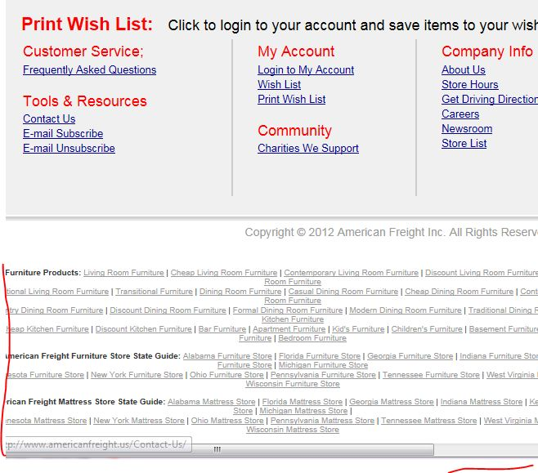

18. Removed border
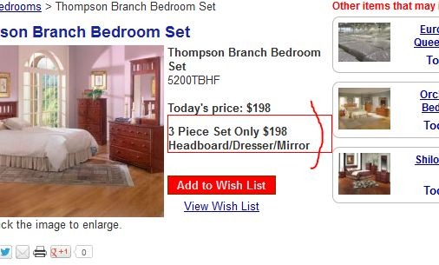
19. lite box is not working
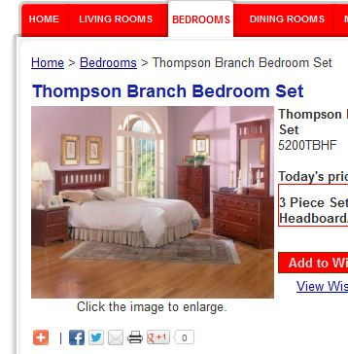
20. Need to removed nb_next
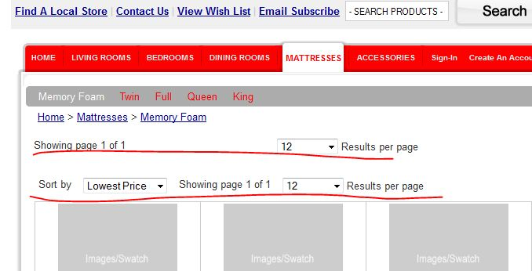

----------Mobile Design ------------------------------------
- In internet explorer change location popup formatting
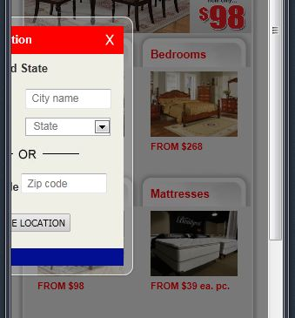

- Need to removed footer and extra links in Connect heading section
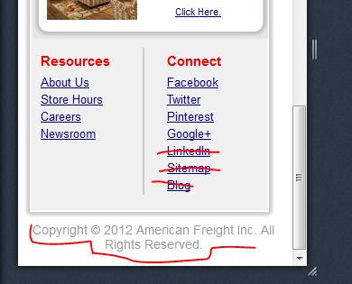

- Alignment and border

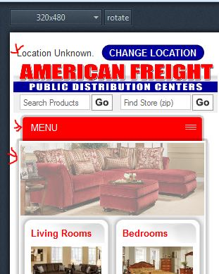

- Find store (zip) is not working. When we search then go to search page

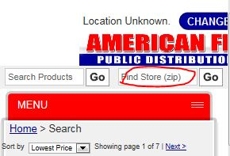

- Menu should be top not search box
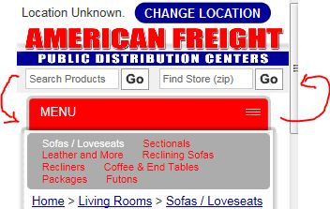

- Need to Page navigation removed
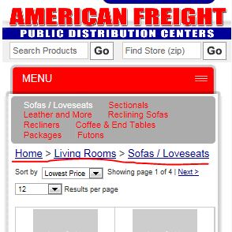

- Need to add “Featured Bedrooms”

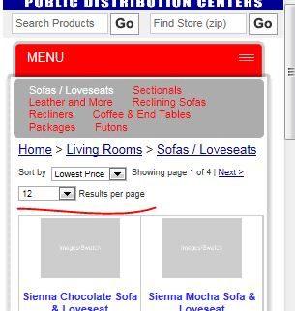

- Removed navigation, background , Map is not working
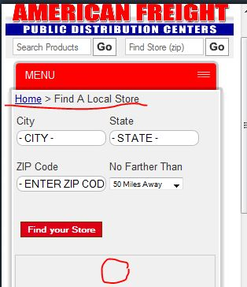

- Need to padding
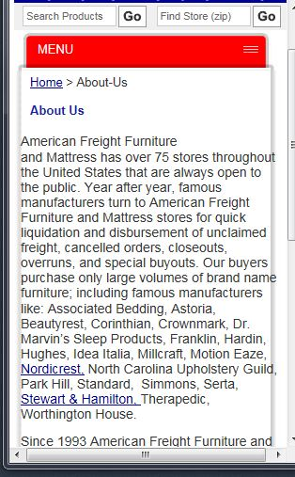

10 Need to reduce spacing
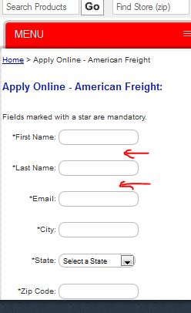

- Removed gray background
