Changes to Tab Layouts/Names and Where Links Reside
I’ve looked at usage and the current tab order and names although good for experienced users has new users lost so I need to change things up as follows:
- Call the current home page “My Stuff” and make it no longer the home page when you log in, instead move the Create Portals page to number one in the tab order. Still call it Create Portals though so there won’t be a page named Home any more.
- On the Create Portals page I want you move the following links and their descriptions (and the icons) to the Other Stuff page
  - Portal Header Mgt
  - Create Forms
  - PortalForce PortalMall
Then on the Create Portals page I want you to re-order the existing links as follows, starting with the top left and moving to the right:
- Manage Portals (description below)
- Create Member Portals
- Create Open Portals
- Create Template Portals
- Content Library
Regarding the Manage Portals, when users click here they should see a page that simply has the bottom of the current Home Page, so the menu bar and then all the portal folders below it as so:
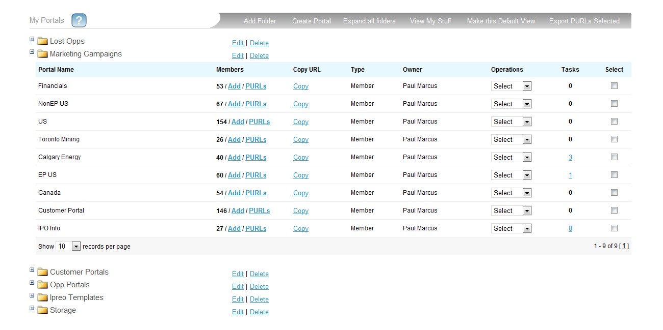
Except instead of saying “My Portals” it should just say “Portals.” Everything else stays the same.
For the icon to the left use the icon we currently have the PortalMall link, and the description paragraph should say:
“This is where you’ll be able to see and manage all the current portals that you’ve created. Click here to view, edit, and delete portals you’ve already made.”

