Default Header and Logo
I’ve learned that sales people are not capable of using a graphics program to create a header, and much of the time even a logo. The most they can do with an image is copy and paste. I’ve lost most potential users because they simply couldn’t figure out headers, they get frustrated, and they stop using it. So I need to create “default headers” which will work more like a social media platform where you just fill in data and the header is automatic and requires no image editing.
Here is what that header is going to look like:
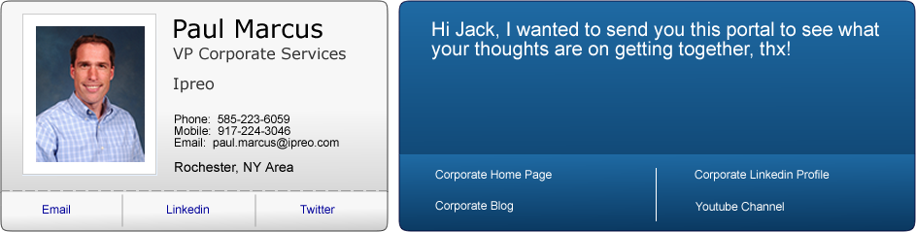
There are really four elements to this header:
- The picture of the user
- The business card data of the user
- The link buttons which take the person viewing to external links
- The headline statement area which is where the “Hi Jack…” is
All of these except the headline statement will be predefined in the user account set up page which will now look like this:
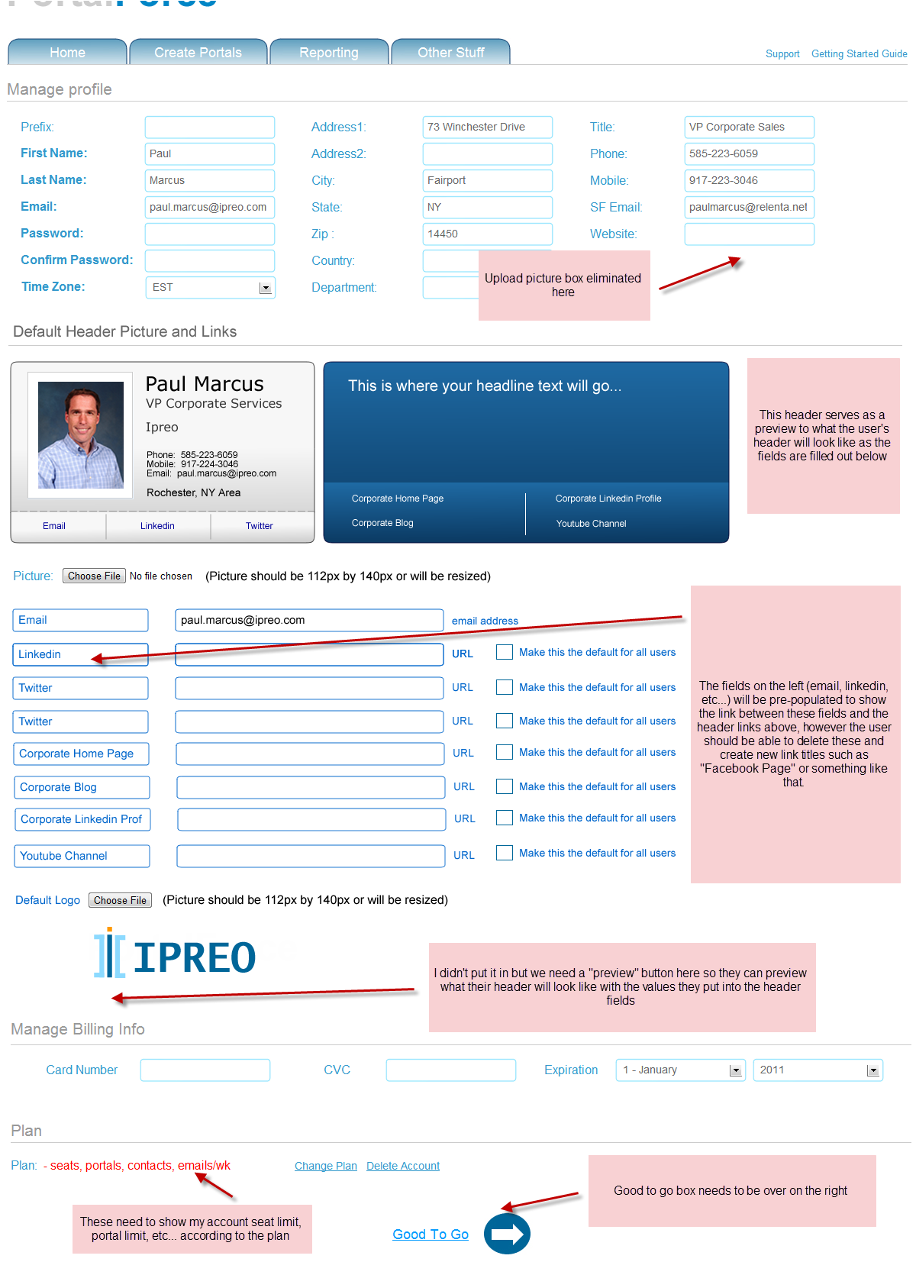
I’ve attached this file in basecamp so you can see a larger image of it, but you’ll obviously see I’ve added a section to set up your default header and logo.
So you’ll see I’ve moved the field where you update your picture, and now the picture will have to be a set size, so if the user doesn’t upload the correct sized picture we need to resize it to fit the area.
Then there are seven link fields, of which 3 are under the business card part of the header, and 4 are under the headline part of the header. The left field is the title of the link, the right field is the actual URL where they link takes the user (in another window as always). You’ll see also that there are check boxes for “make this the default for all users.” These check boxes should only be in the Manage Account page for admins, and if one admin changes this, it obviously changes this for the entire company. However, EVERY user should have the option to overwrite these default settings and put in their own links.
You’ll also see they user will upload their company logo here. Again, this should only be done for the first user/admin. Once they’ve done it then the logo should automatically be there for all future seats added, but again, individual users can change this for their specific account.
When a user logs into PortalForce for the first time it should take them to this page and ask them to complete all of the fields.
Impacts to the Create Portal Process:
Now this is going to impact that create portal process page. I’m doing the following here:
- I’m eliminating confusing options and putting them into expanding/collapsible section called advance options. Users will still be able to choose a non default logo or header from header mgt for example, but it will only be in this advance section. Otherwise the system should automatically use the default header and logo.
- I’m still allowing the user to enter in a headline but it’s a fixed size box with only the ability to control the size of the text and the line spacing, nothing else. This way when the box is full they can’t type any more. No more worrying about tables or layering text over an image they can’t see.
- Because of this I’m also adding above the headline box the option to make the header dynamic by contact owner where the prospect that logs in would see the header of the user owner, or if that option isn’t chosen then you can manually choose the default rep header you want to use if you’re not creating this portal for yourself.
Here’s what the page should look like. I have the advanced section expanded but the default should always be closed, note that I don’t have the header editor in advanced options here but it should be there:

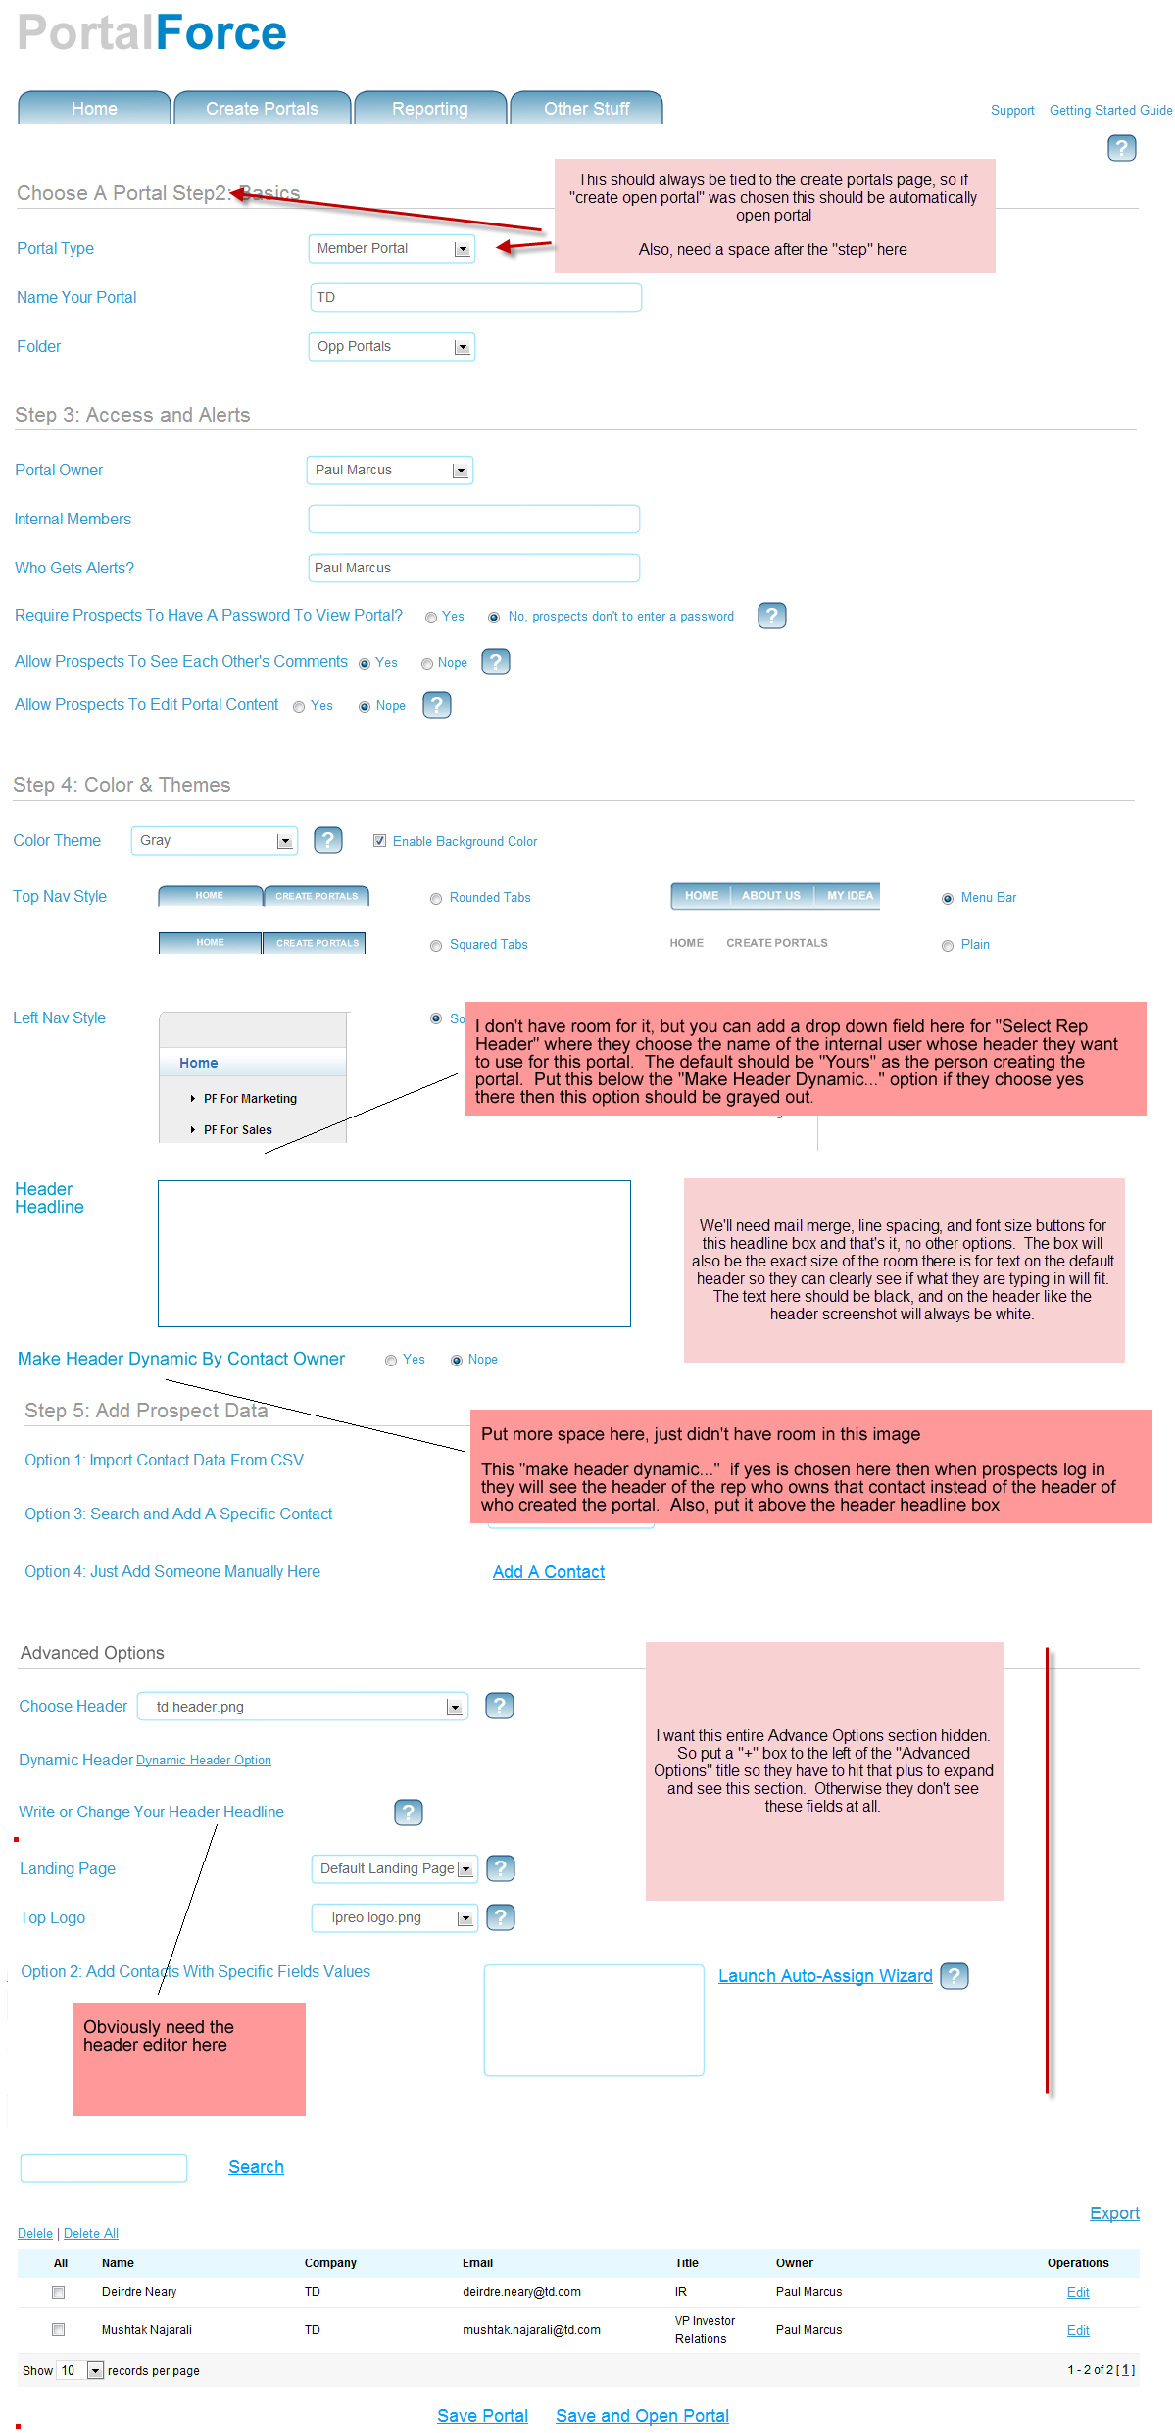

So portal mgt would stay the same, and would be there for advanced users. If a user in the advanced section choses a header for portal management (or logo) then that header would be used instead of the default one. Otherwise both the Choose Header and Top Logo field here should just say “Default.”
It should also be noted for choosing a header that in the advanced section, the user should also have an option for “No Header” here if they want.

