Some Problems With Chrome
In my portalforce account look at any of the pages in the content library that say “The New Sales.” There’s somehow an Anchor on the page in chrome where every time you open it it opens at the middle of the page. Can you let me know what the problem is here?
Also, in Chrome, you can’t copy and paste any of the formatting. When you paste it all formatting is removed. Can you fix this as well.

Bugs
Here are bugs I have found thus far:
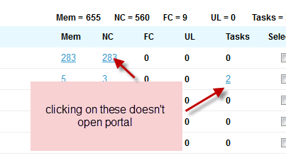
This has fixed.
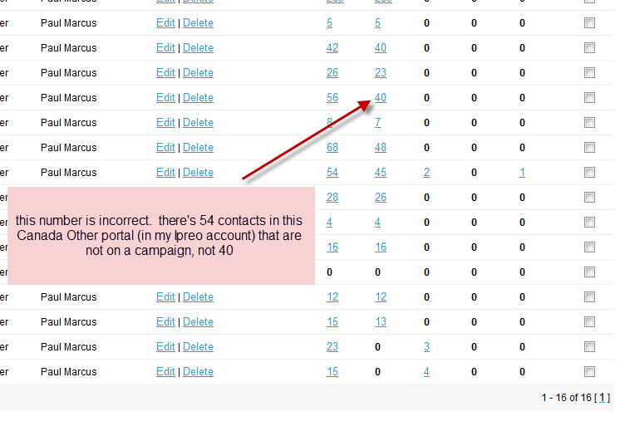
Not Completed.

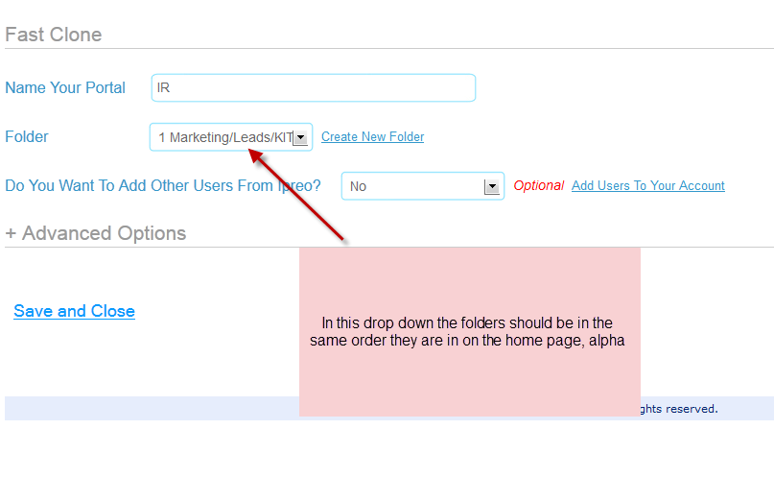
Completed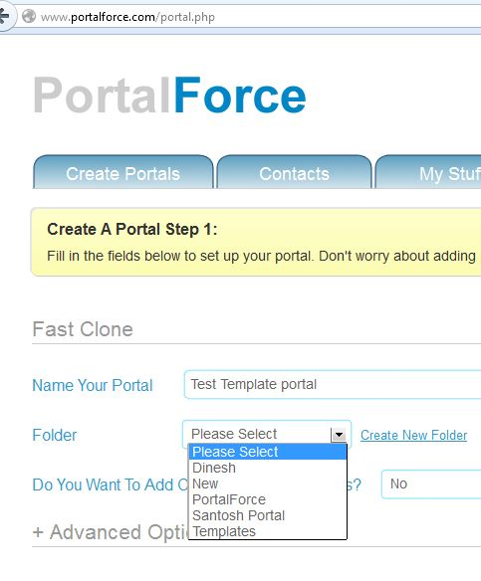
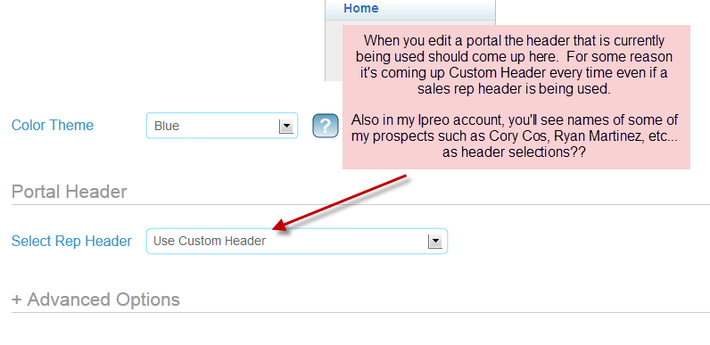
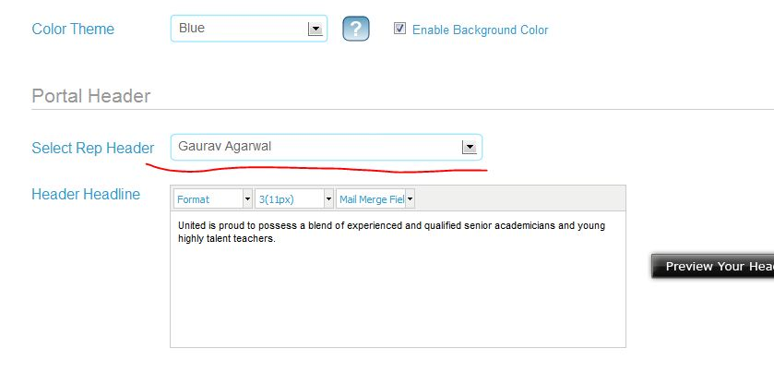
This is fixed but, Need to update portal for view this changes
Completed

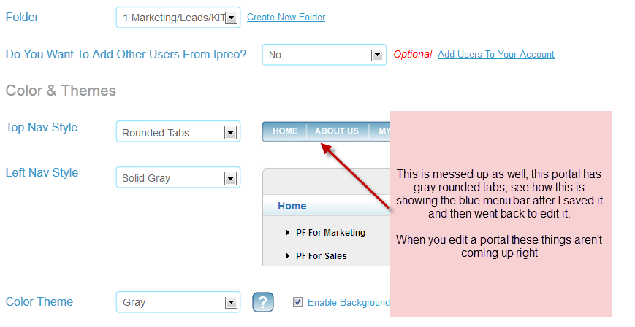

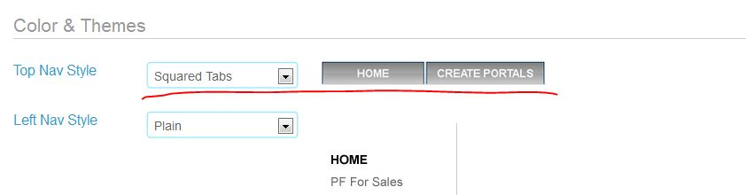
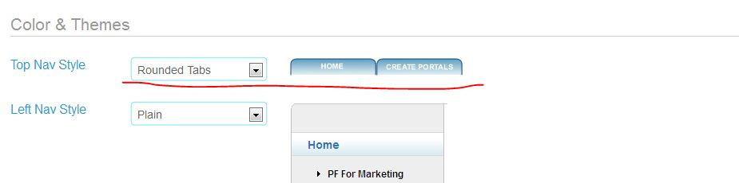
Completed
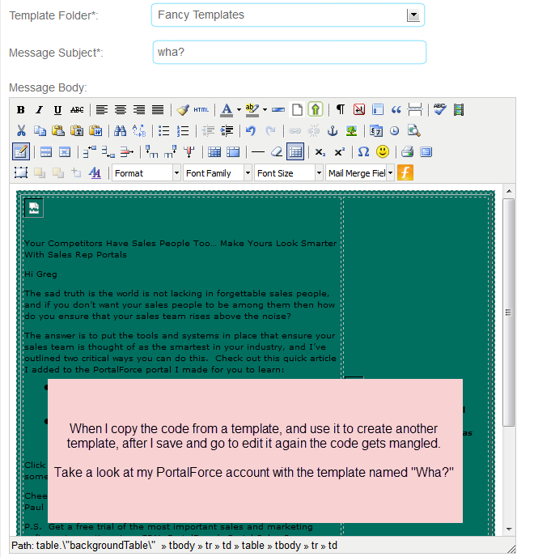
Not Completed
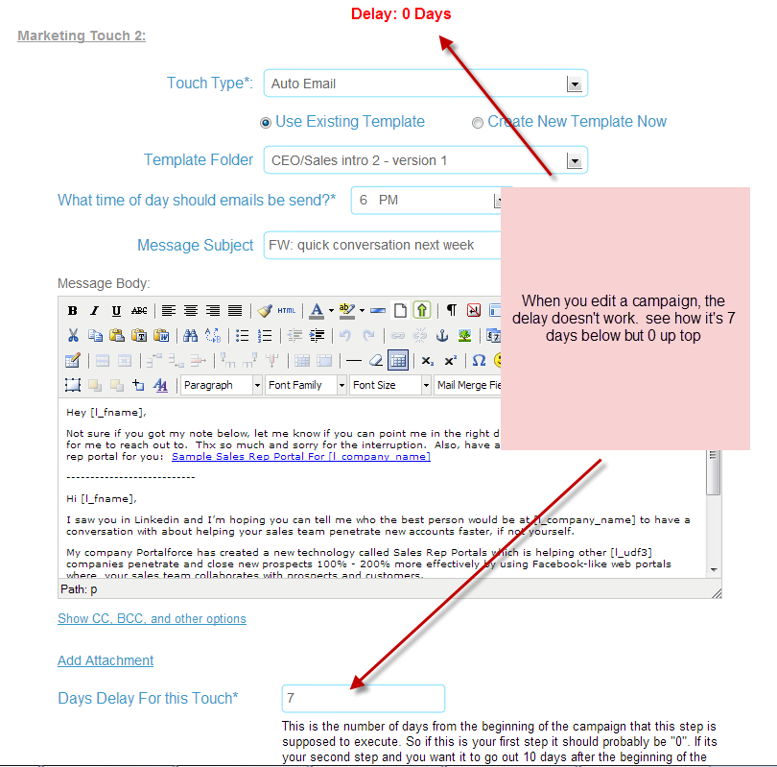
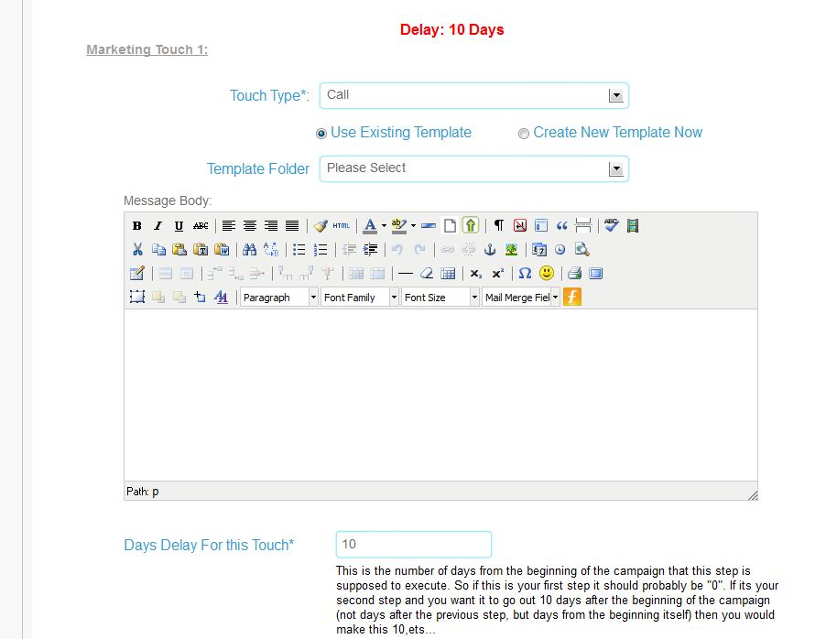

This has fixed.

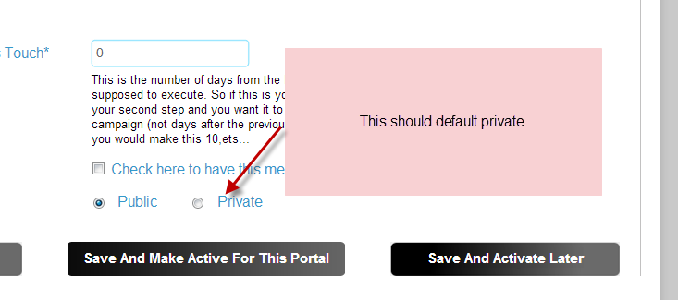

Completed
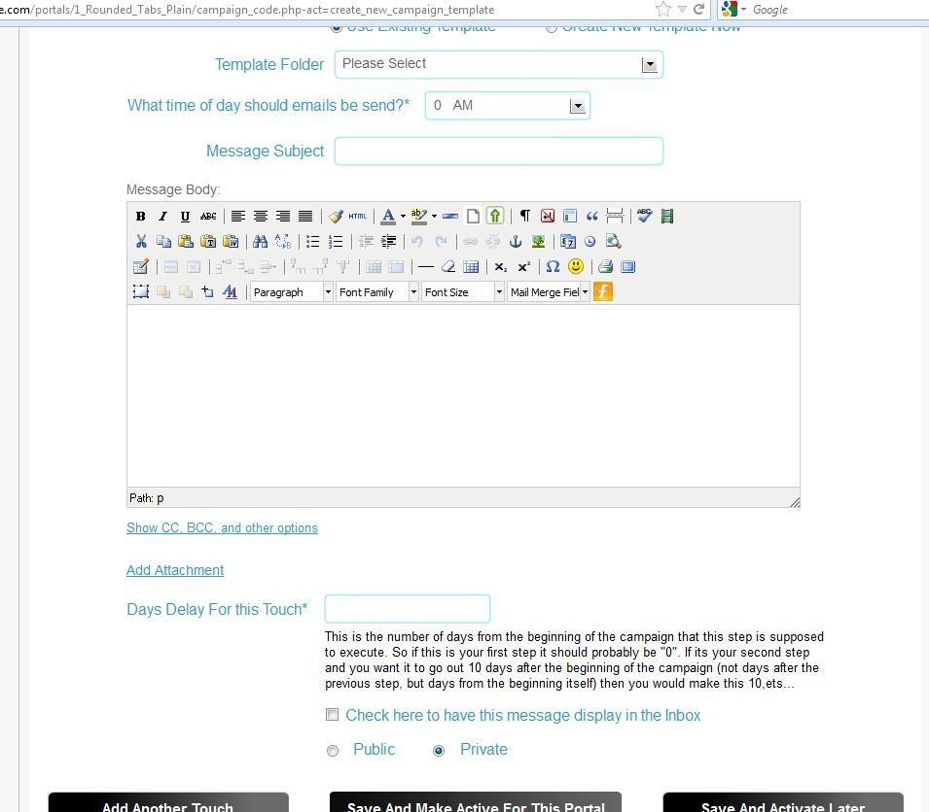
Completed

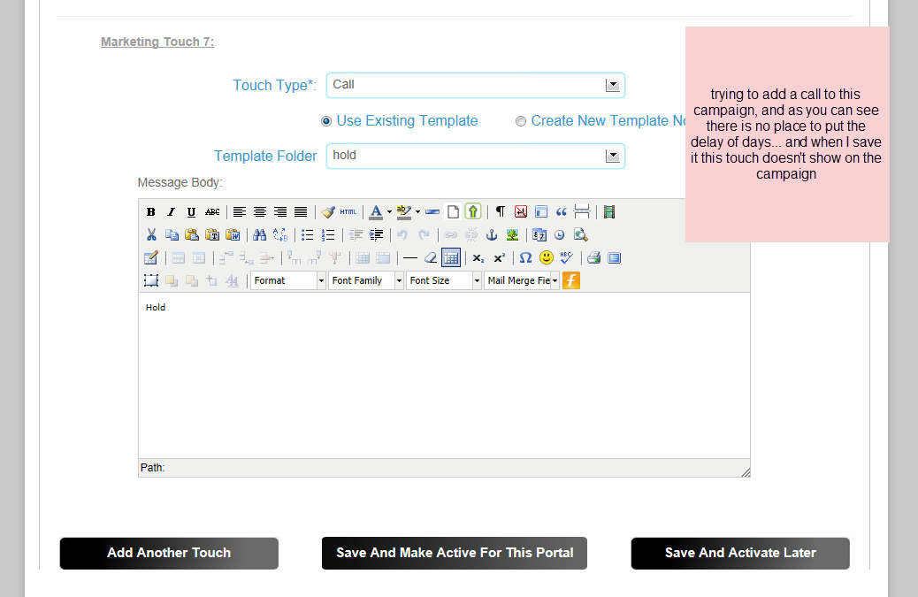
This has fixed.

