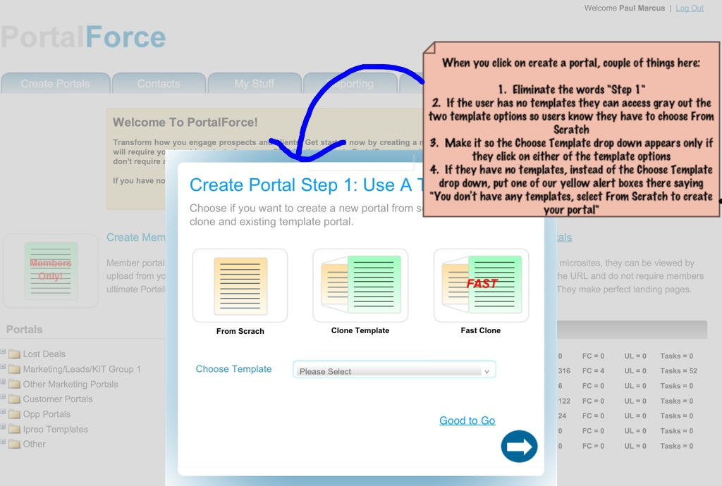
- Make it so the Choose Template drop down ONLY appears if the template options are clicked on
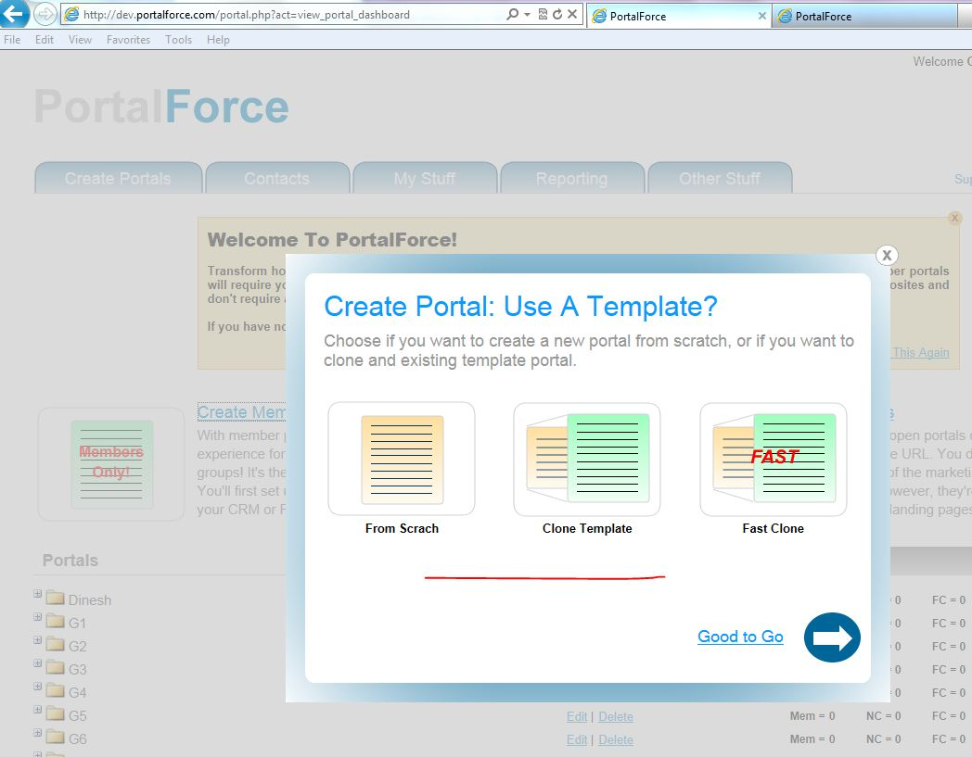
Completed

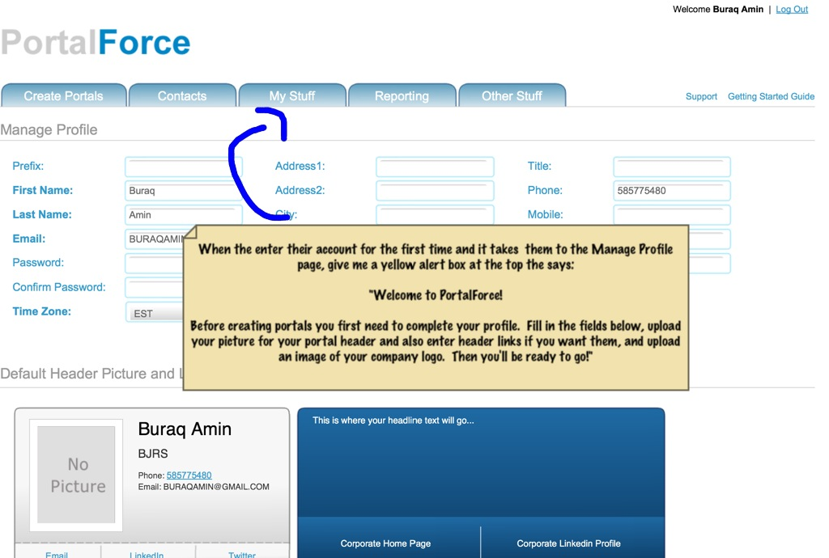
- For this alert box can you bold the first line and leave a space between it and the main paragraph
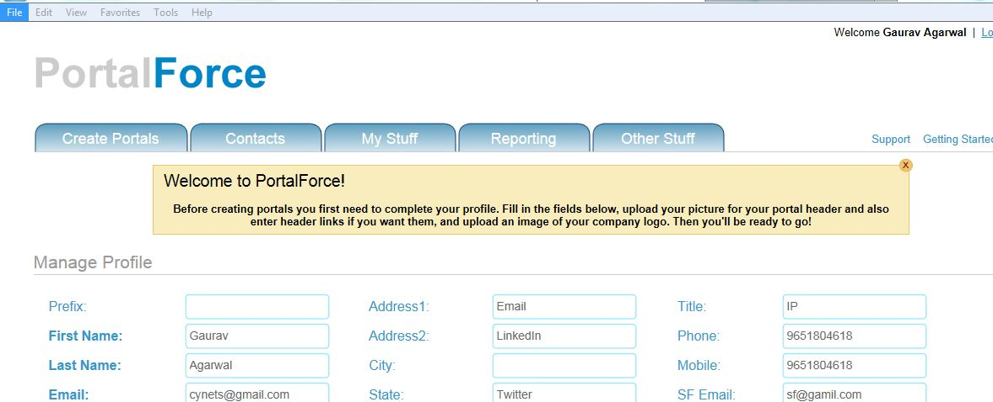

Completed

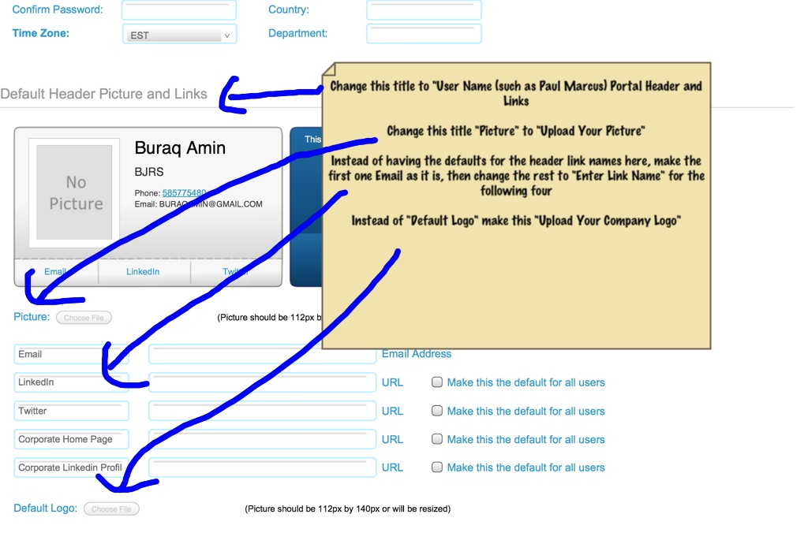
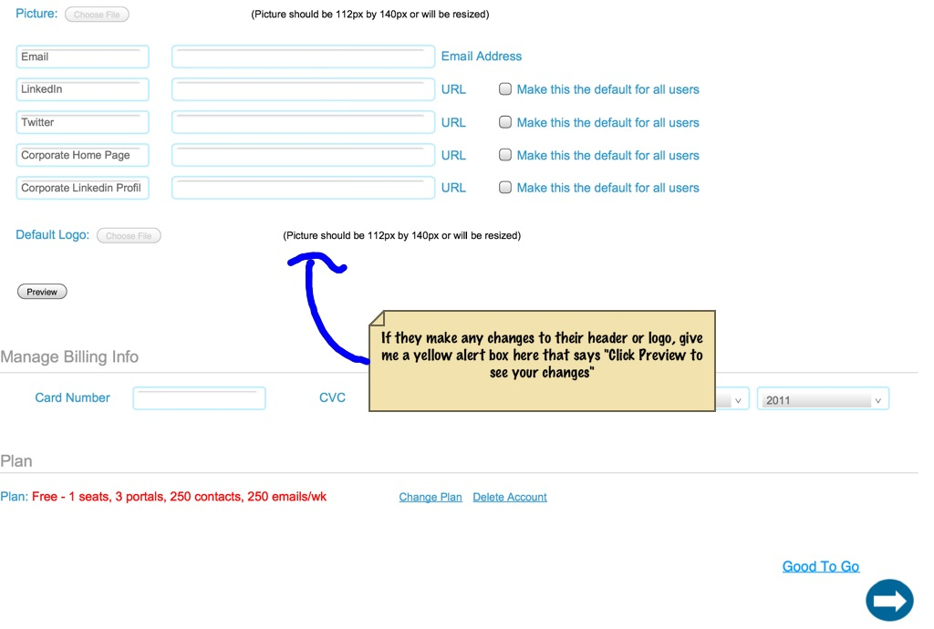
- I didn’t see this box pop up when I changed one of the links

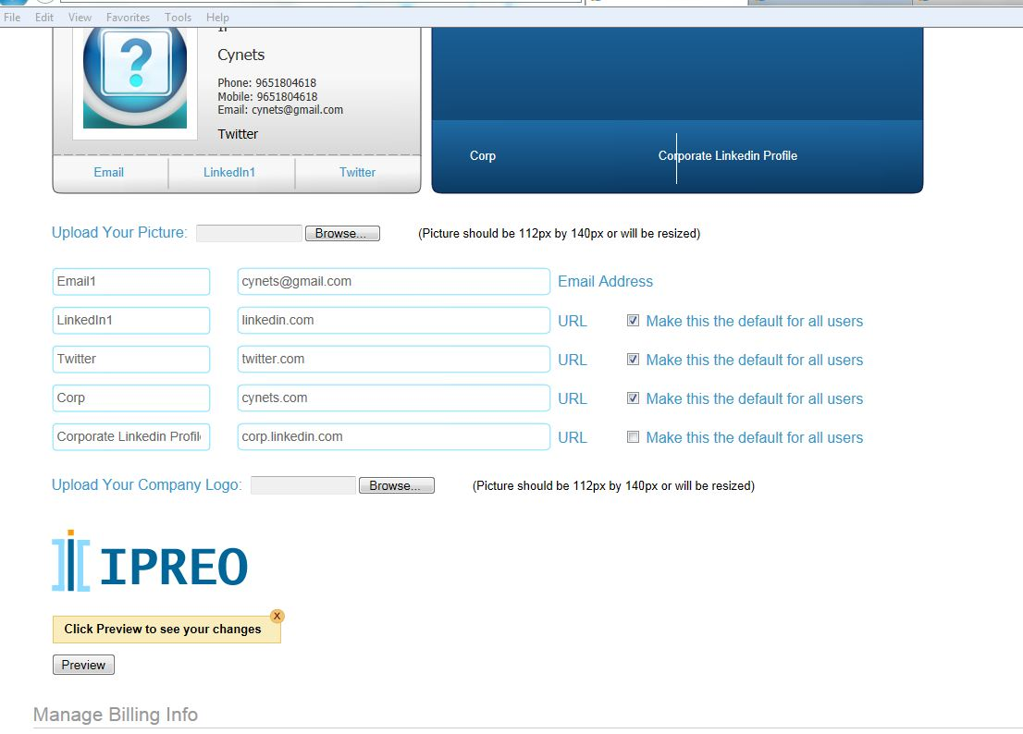
Completed
Now popup come out when any fields edit.

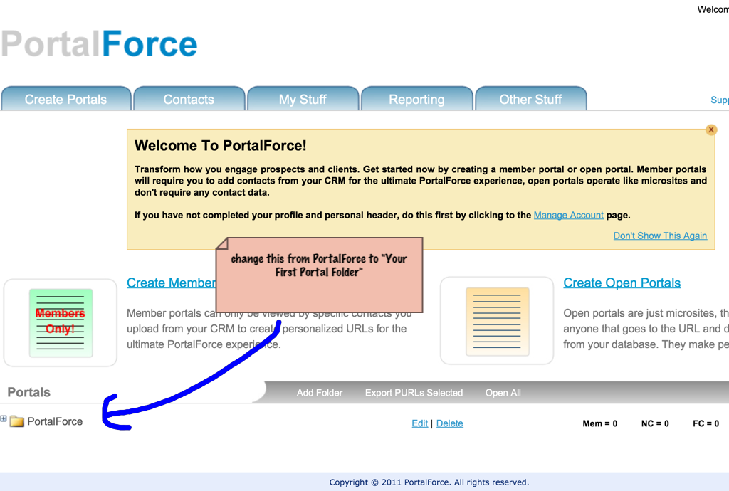
- When I went to this page there was no portal folder at all

This is come when we create new Client.
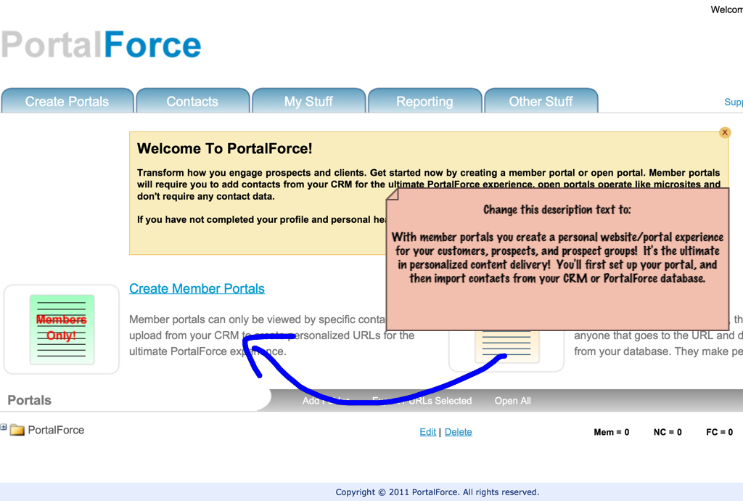

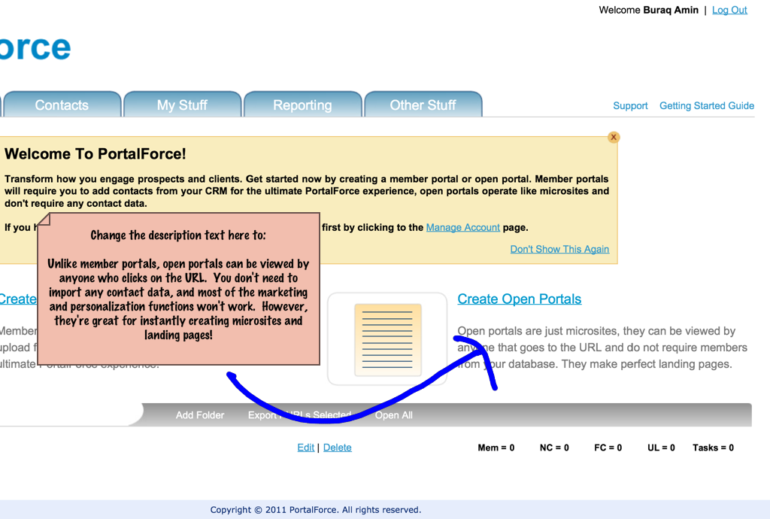

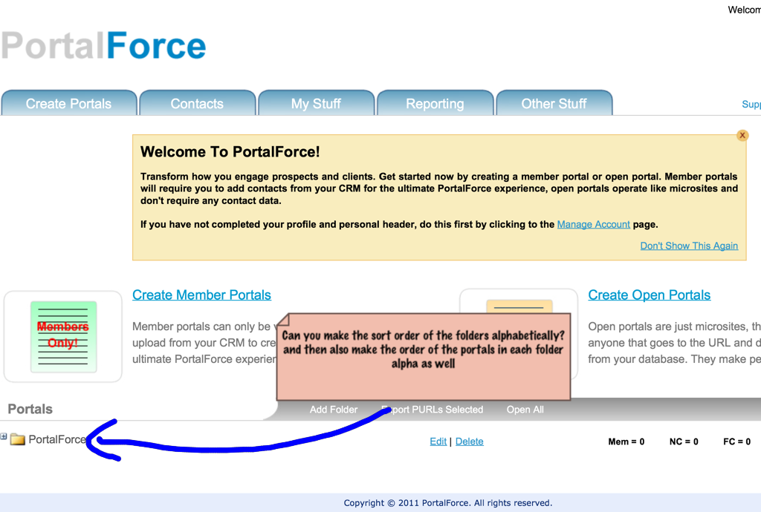
I should also note here please make all the sorts alpha, such as in templates, campaigns, etc…

Portals list , templates and campaign short by name ASC
Templates
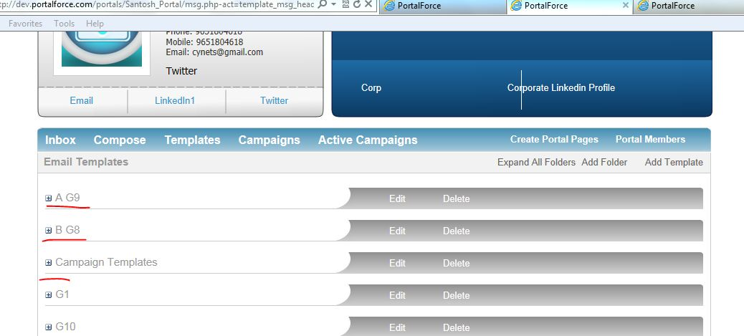
Campaign
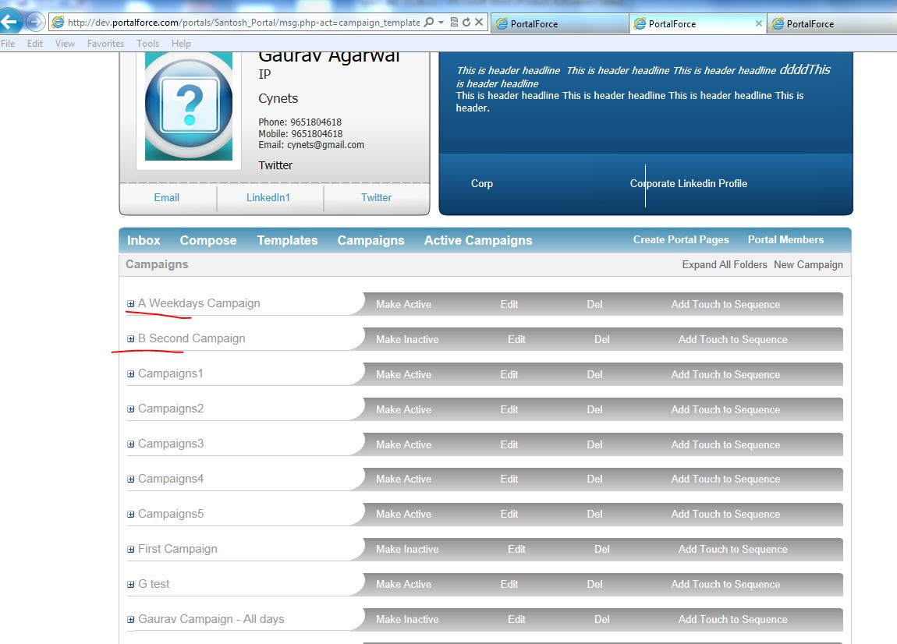
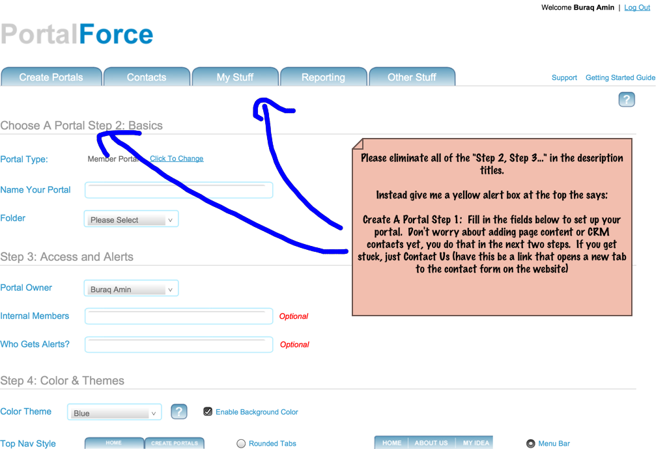

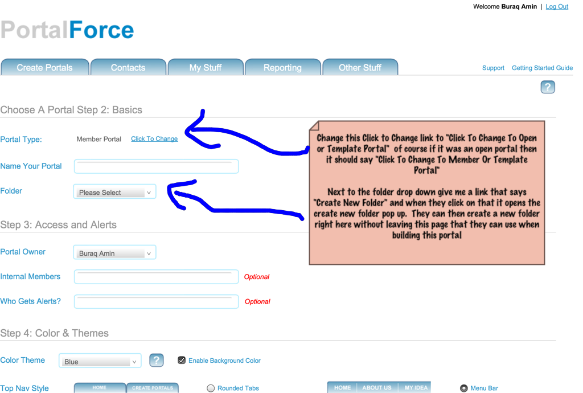

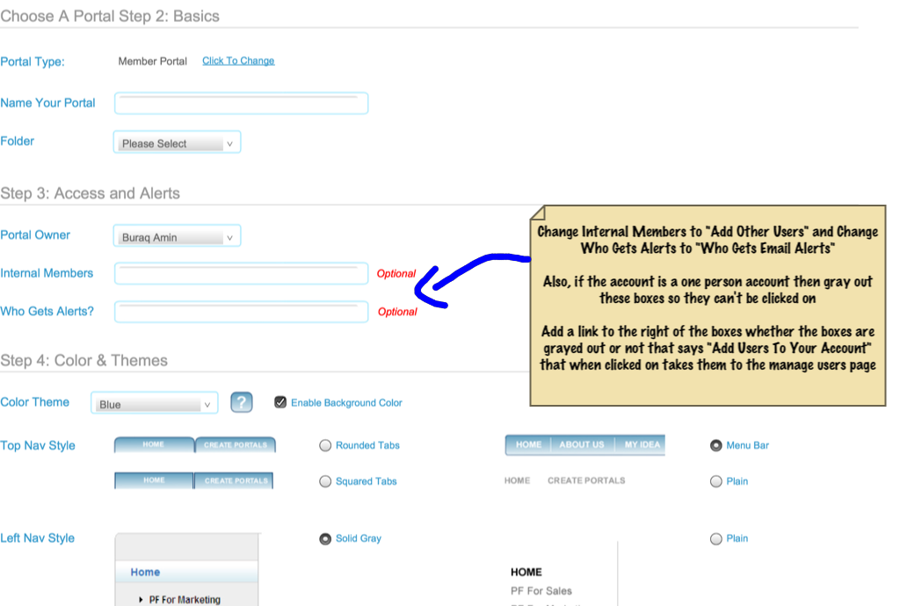
- These boxes still need to be grayed out if it is a one person account, right now they are still active
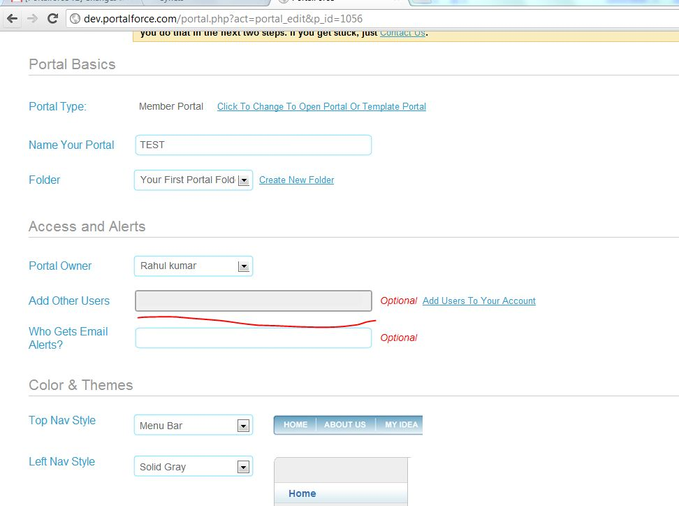
I have fixed it
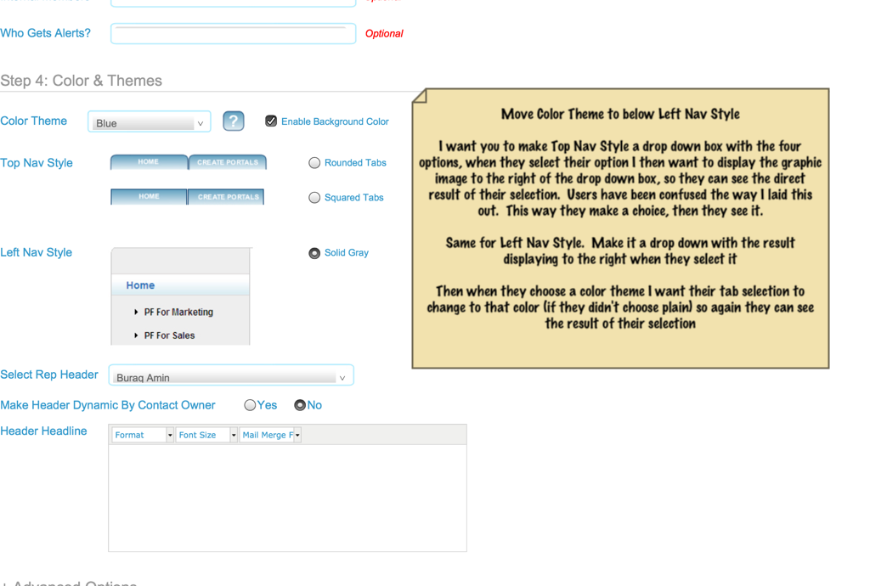

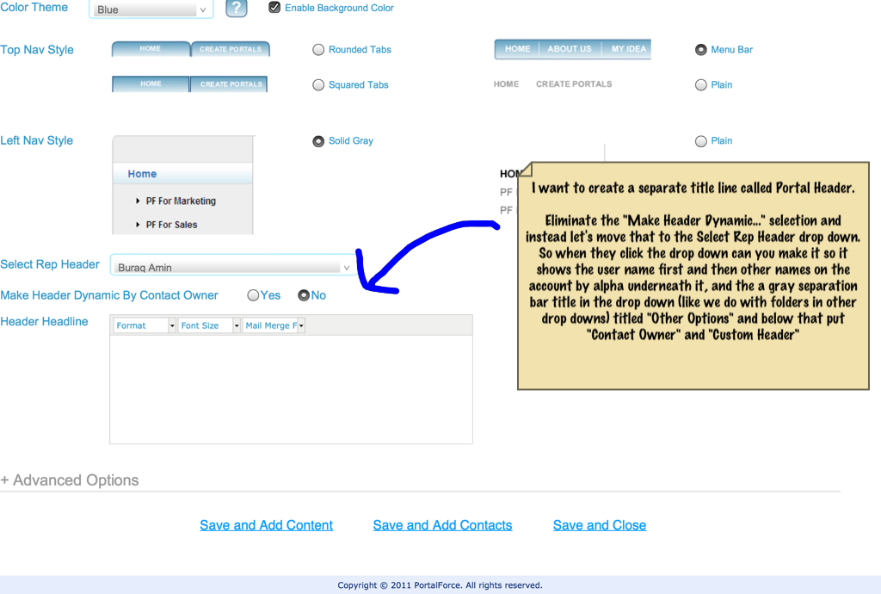
- These changes weren’t made Gaurav
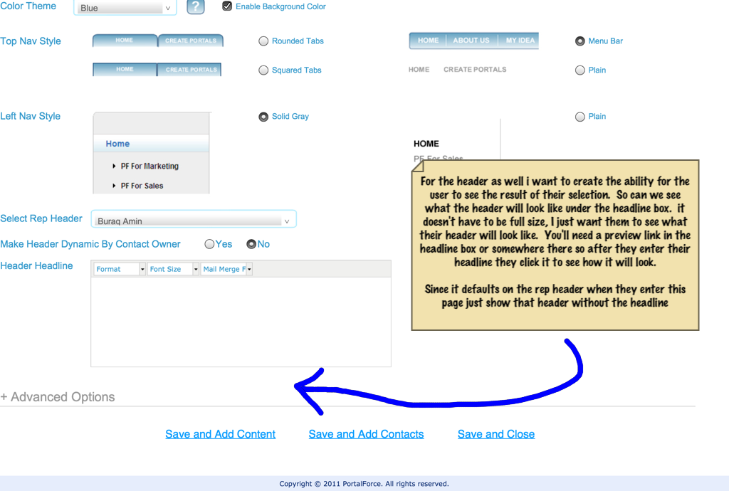
- For this Gaurav I want an actual picture of the header here so they can see what the header looks like here instead of opening a new window (just a smaller version of the header so it fits). Or if that is too difficult make the preview header not a link, but a very obvious button that says “Preview Your Header.” Make the button to the right of the header headline box so it sticks out
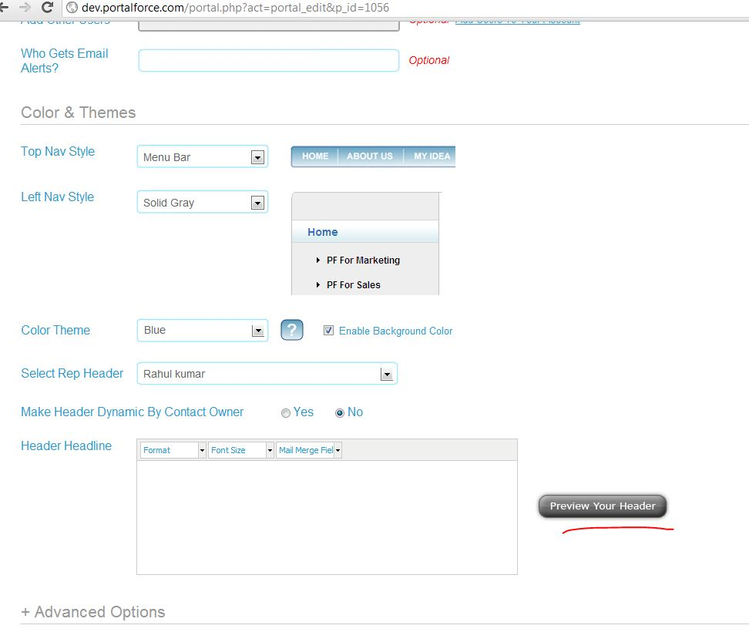

Here only change link to “preview ” to ”Preview Your Header” button
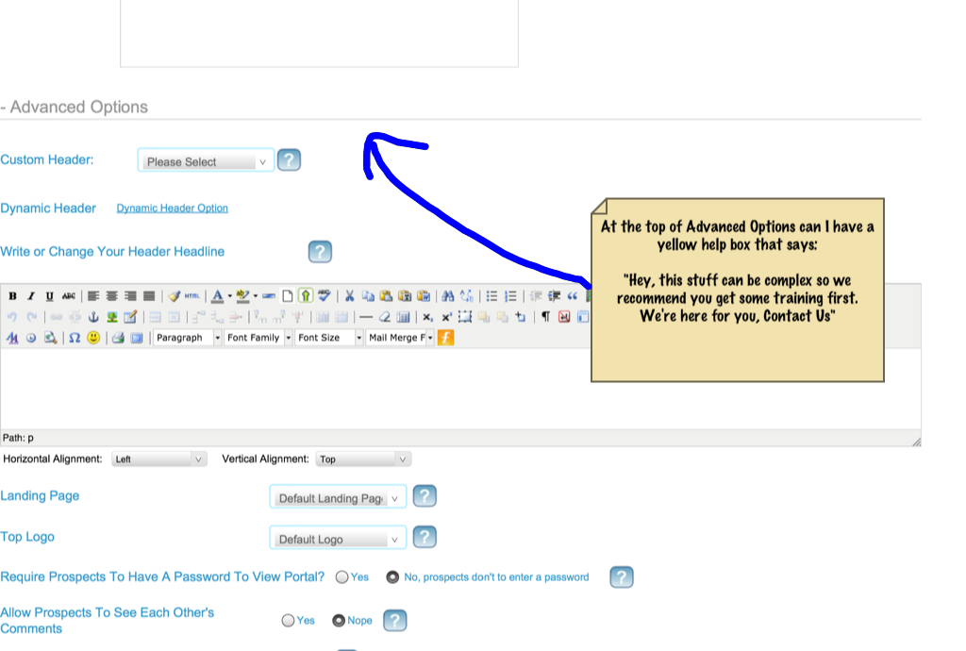
- Center this alert box Gaurav
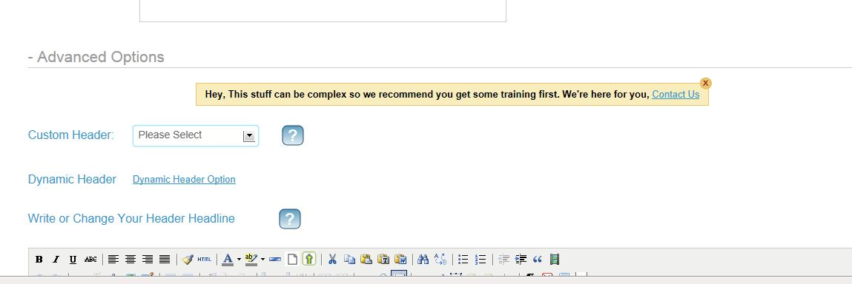

Completed

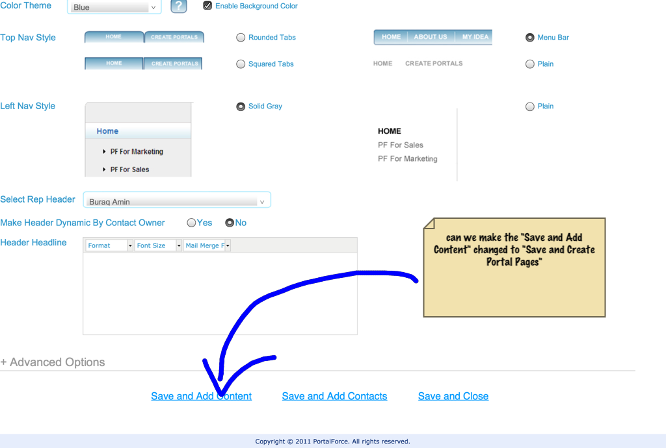
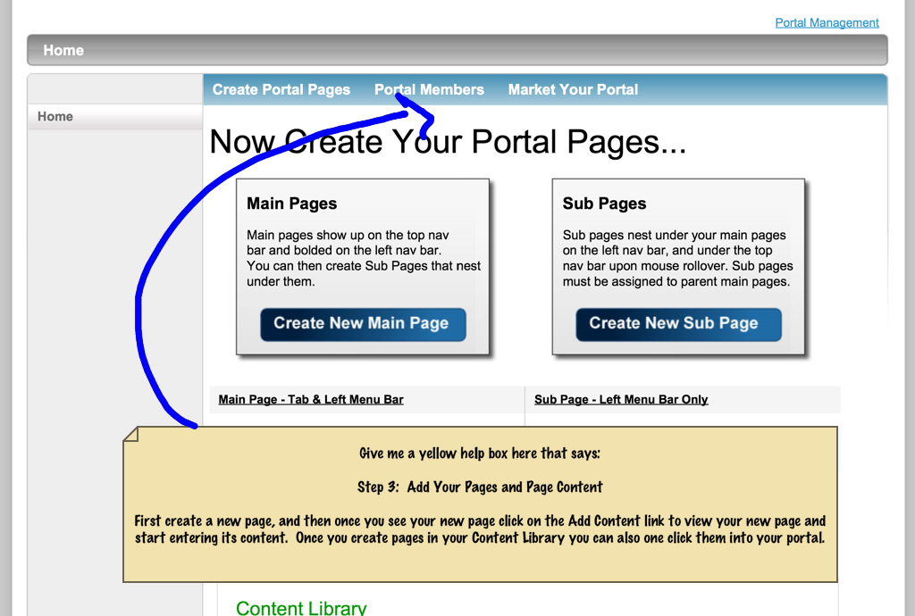
- Sorry, don’t center the text on this box. Make like all the other alert boxes
- Also, bold the first line as usual
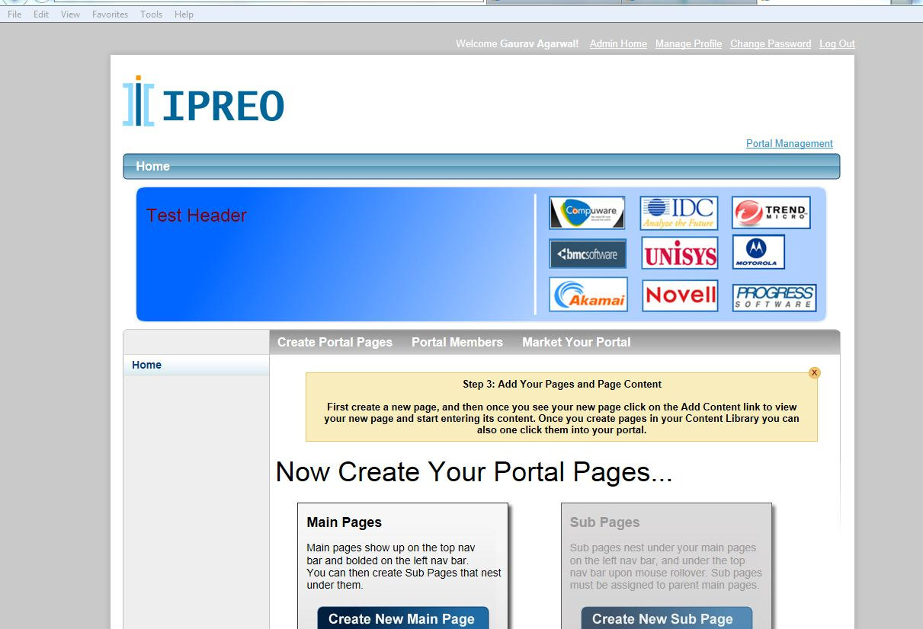
Completed
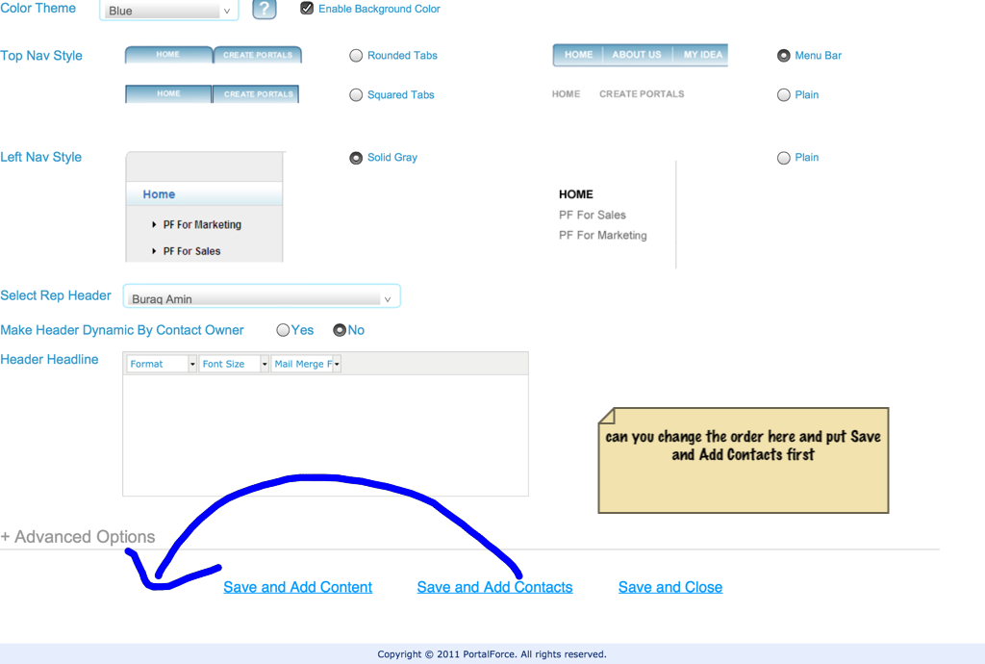

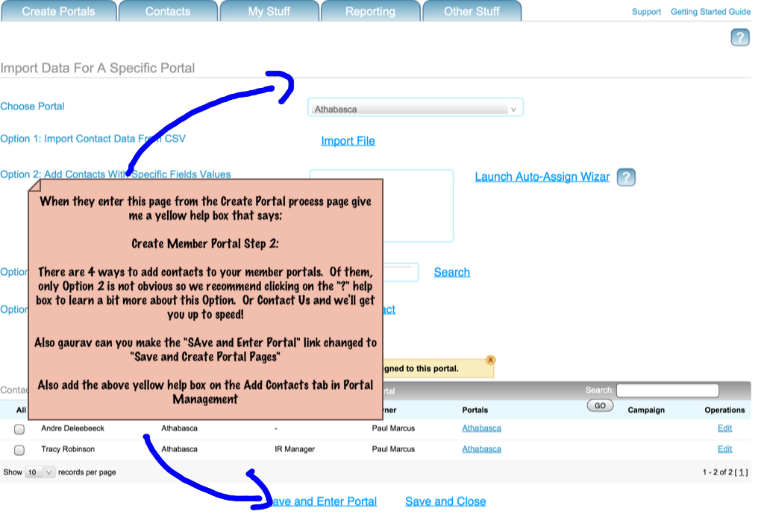
- Again, can you make the alert box consistent with the look of all others. Right now the entire thing is bolded. All these boxes should look the same. First line bolded, then a space, then rest of text unbolded. Make sure fonts are all same as well
- Also need this box in Portal Mgt portal members section
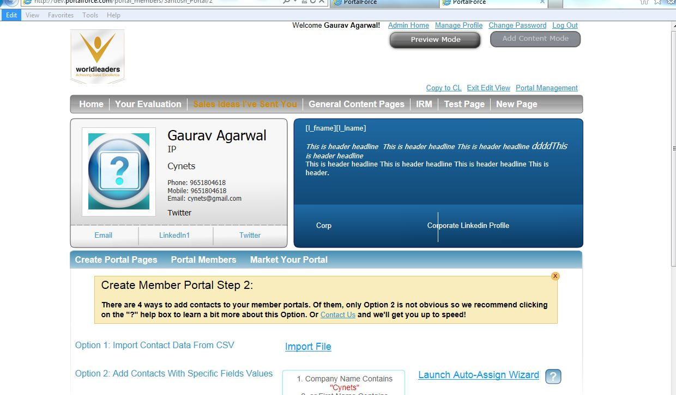
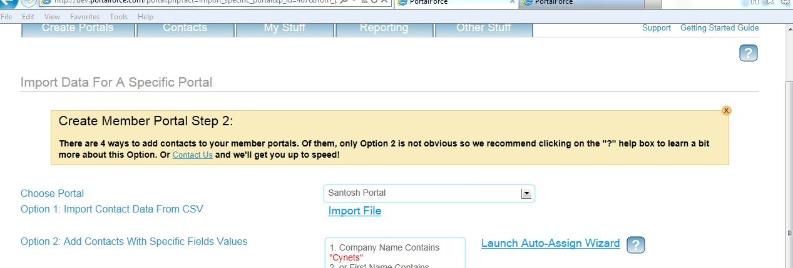
Completed
