Some Problems With Chrome
In my portalforce account look at any of the pages in the content library that say “The New Sales.” There’s somehow an Anchor on the page in chrome where every time you open it it opens at the middle of the page. Can you let me know what the problem is here?
Also, in Chrome, you can’t copy and paste any of the formatting. When you paste it all formatting is removed. Can you fix this as well.

Formatting Issues
Need to fix some formatting issues in all the browsers:
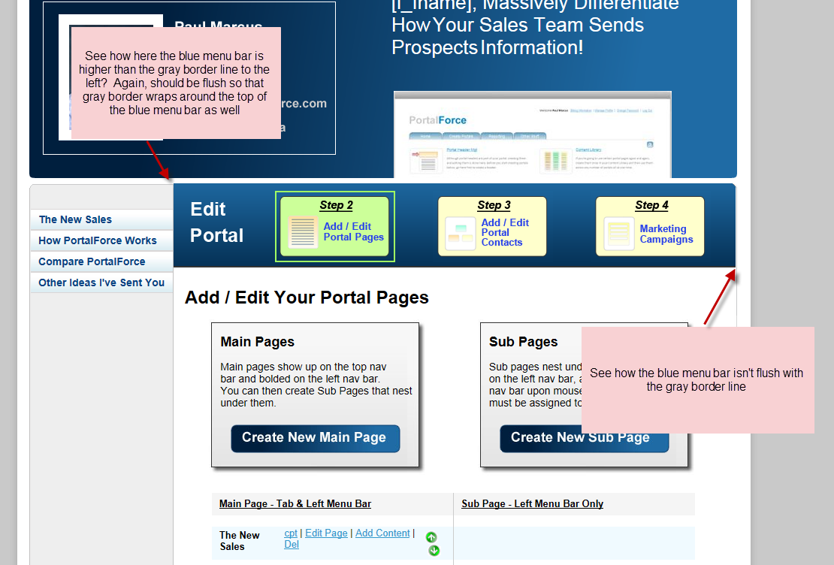
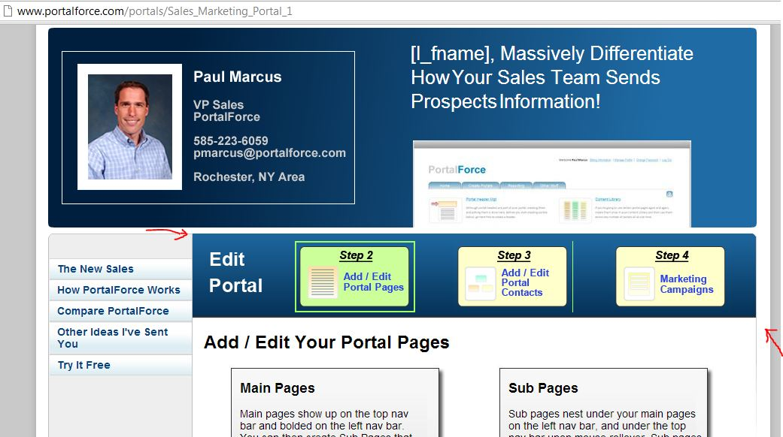
Completed

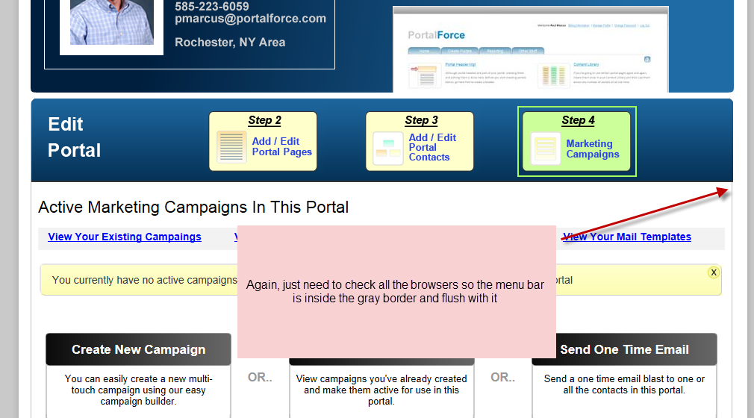

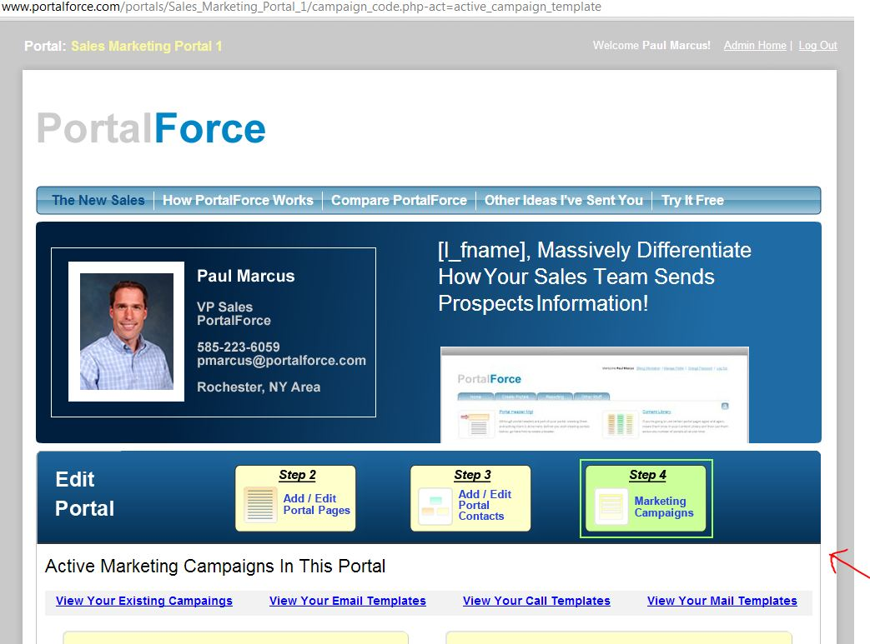
Completed

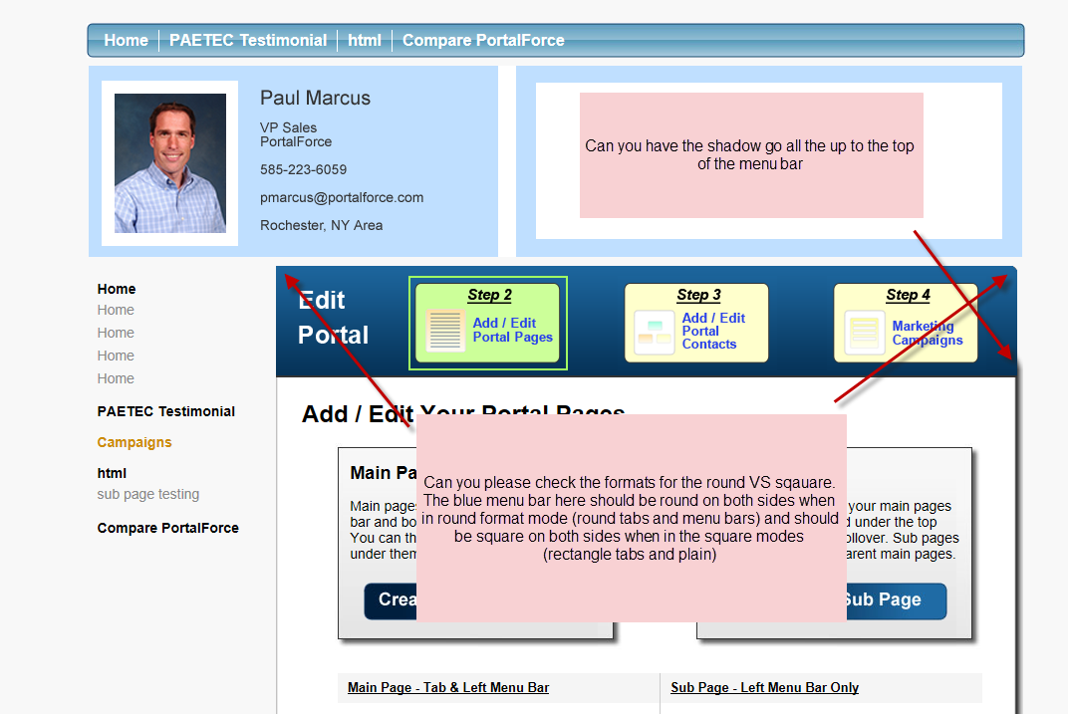
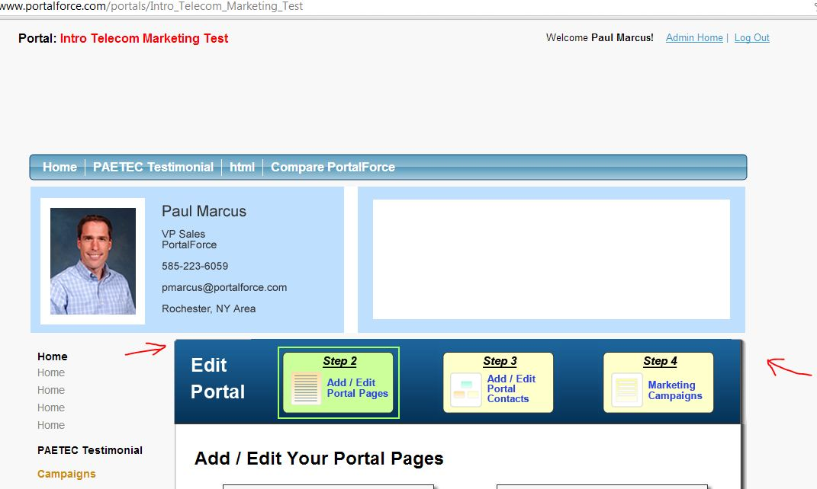
Completed

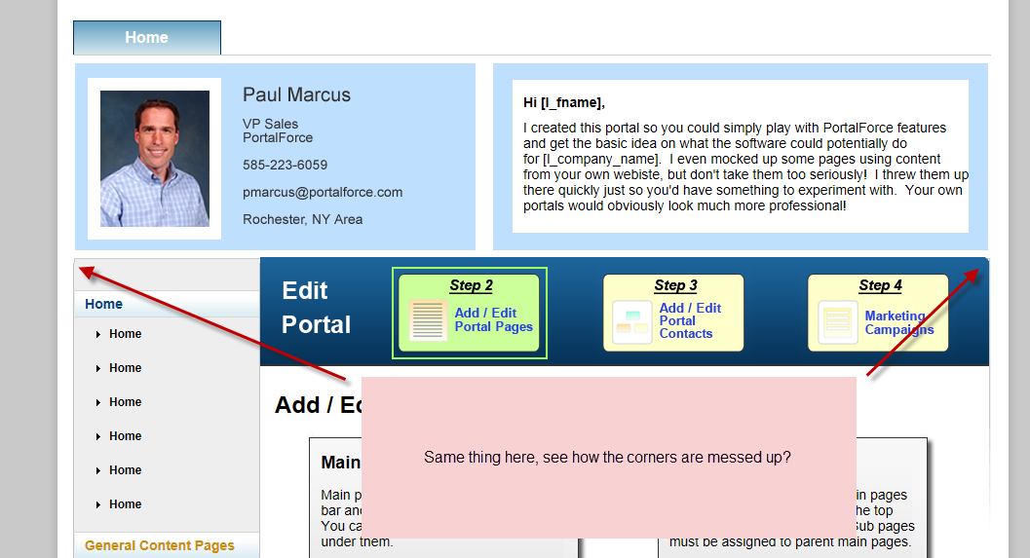
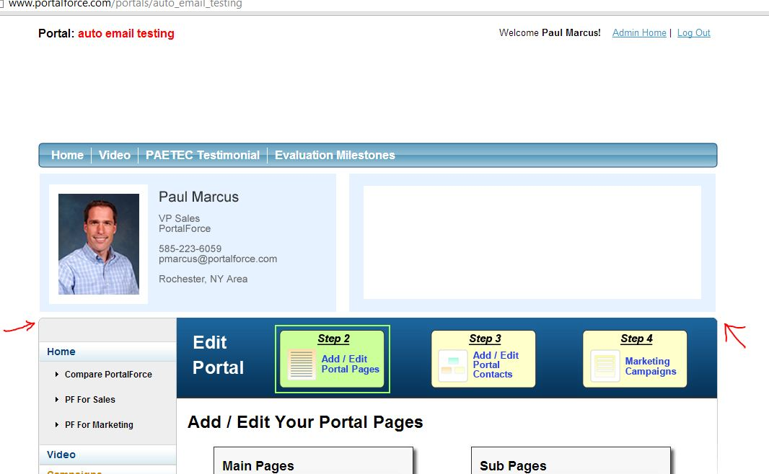
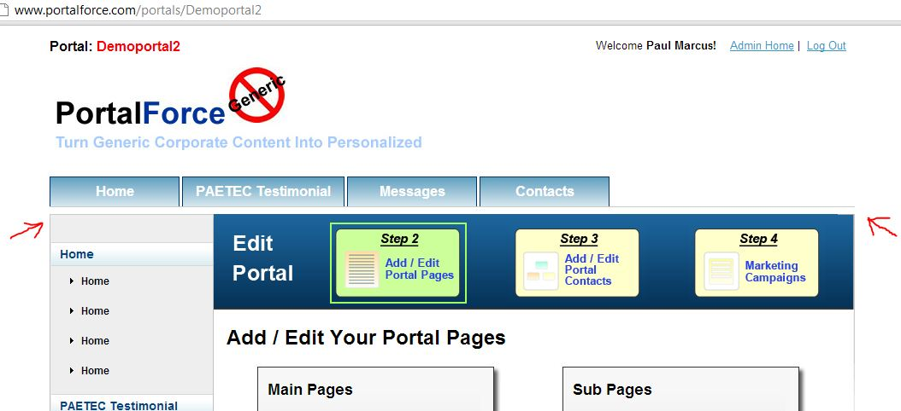
Completed

