Scope Of Work
GT Tire Online Training Portal
Updated: 10/4/12
Project Goals:

A dual-language online training portal for company employee education. Testing to demonstrate competency and reporting for internal accounting will be included. Site dimensions are modeled after www.gtradial-us.com and must use similar framing.
Working beta by October 19th. Final beta site due no later than 10/23/12.

Public User View:

- Language choice option (Similar to: http://toyotraining.ca/) Registration languages (English, French) Done
- Integration of custom design as needed throughout. (PSD files provided) Done
- Login allows remember me link. Username should appear, but not password, next time they log in. Tab key navigates through dialog. Enter accepts and logs in. Done

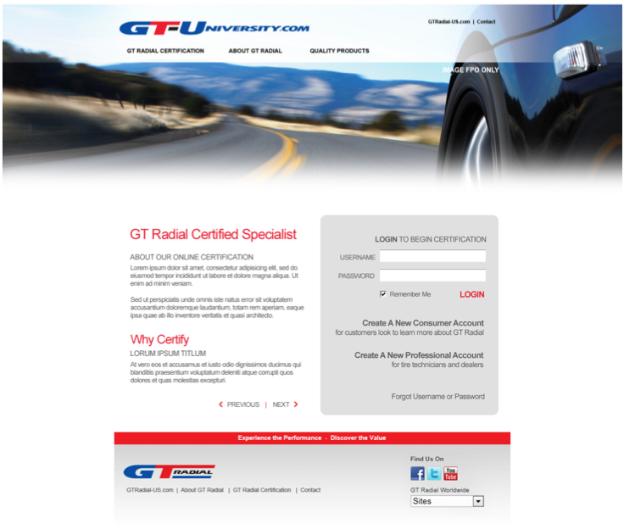
- Registration (aka enrollment): Accounts based on email address and password. Done
- Registration: Sign-up page, include options for 5 user types: Consumer, Passenger and Light Truck Dealer, Commercial Dealer, Dealer All Done
  - Needs nice visual confirmation message on screen to indicate successful registration. Popover that appears for a few seconds?
  - Consumer users will be activated automatically. System will send branded “welcome email”. (multi-language)
    - There are two choices for user accounts in the login screen graphic above. Consumers will be routed through this log-in.
    - Consumer information should be stored in a different table.
  - Consumer messages should be managed through the admin site. – in the System Emails section.
  - The System Emails section in the admin should include categories for Consumer Emails, Passenger and Light Truck Dealer Emails, Commercial Dealer emails and Admin emails.
  - When a Passenger and Light Truck Dealer, Commercial Dealer, or Dealer all enrolls …
    - Sends branded “thank you for enrolling” email (Multilanguage) with instruction to wait for approval
    - Sends admin alert for approval
    - User has to be activated by admin,
    - Upon activation, the user gets branded welcome email with username and password
    - Passenger and Light Truck, and Commercial messages are managed through their respective System Email sections in the Admin App.

Done

- Registration: Choose from approved dealer list (based on unique name managed within Admin Settings section of the site) Not Done
- Sign-up form similar to toyotraining.com – but has additional fields for store number and job classification Done
- Job classification will be based on menu of unique names, managed through the admin application Done
- Button should change from “Save and Update User” to “Register Now”. Done
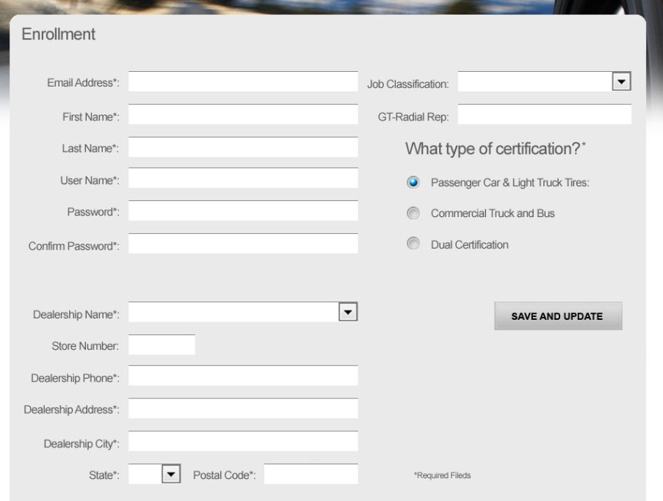
REGISTER NOW

Registered User View:

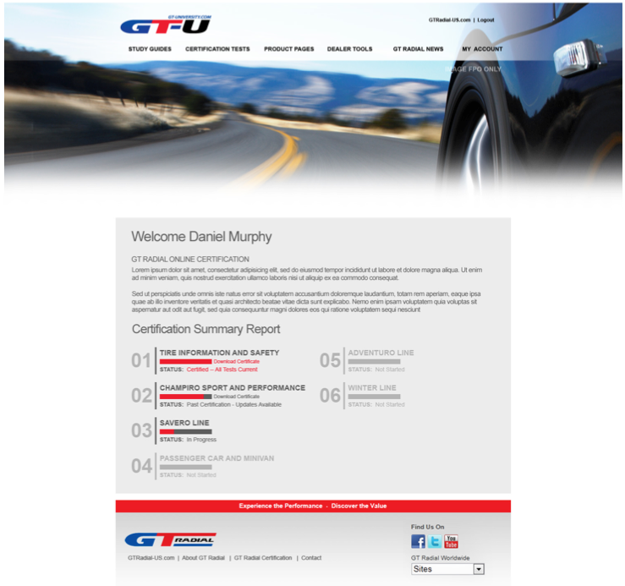
“Full Certification” shows here in red when true.
Download Certificate shows here.

- After login, users will only see menus and tests relevant to their user type. Done
Note that Boomerang would like to manipulate the menus for each user type by editing the actual code – just like we do on ToyoTraining.com via the User Index pages created by Sanctuary. This way we can quickly add study guides, and update menu links.
- Progress bar will show progress to certification. ) Not Done
- Upon completion it will show link to download certificate. ) Not Done

Study Guides) Not Done

- When a user selects a study guide from the Study Guides menu, they are linked to a PHP Study Guide TOC
- Sanctuary to provide two study guide templates as shown below.
  - One for the TOC
  - One for the rest of the Body pages of the Study Guide
- Both the TOC and Study Guide Body pages can link to a background image shown only by that study guide. Note that a second, black and white image will be used for the Body pages.
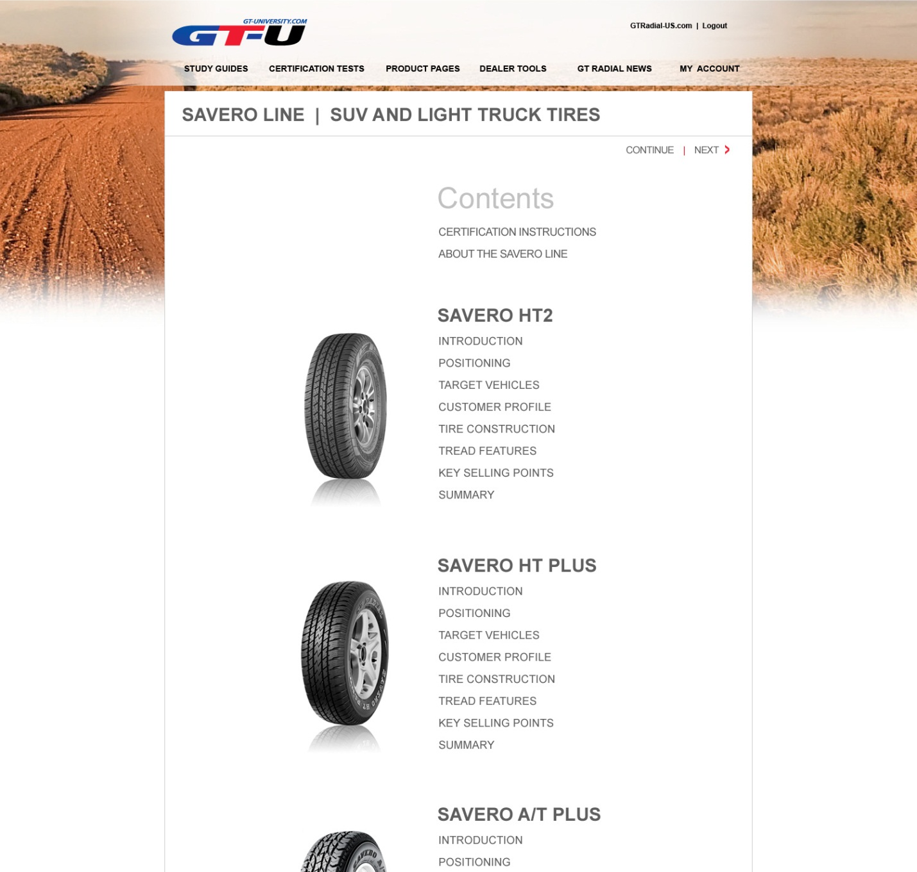

- Second Study Guide page example. ) Not Done
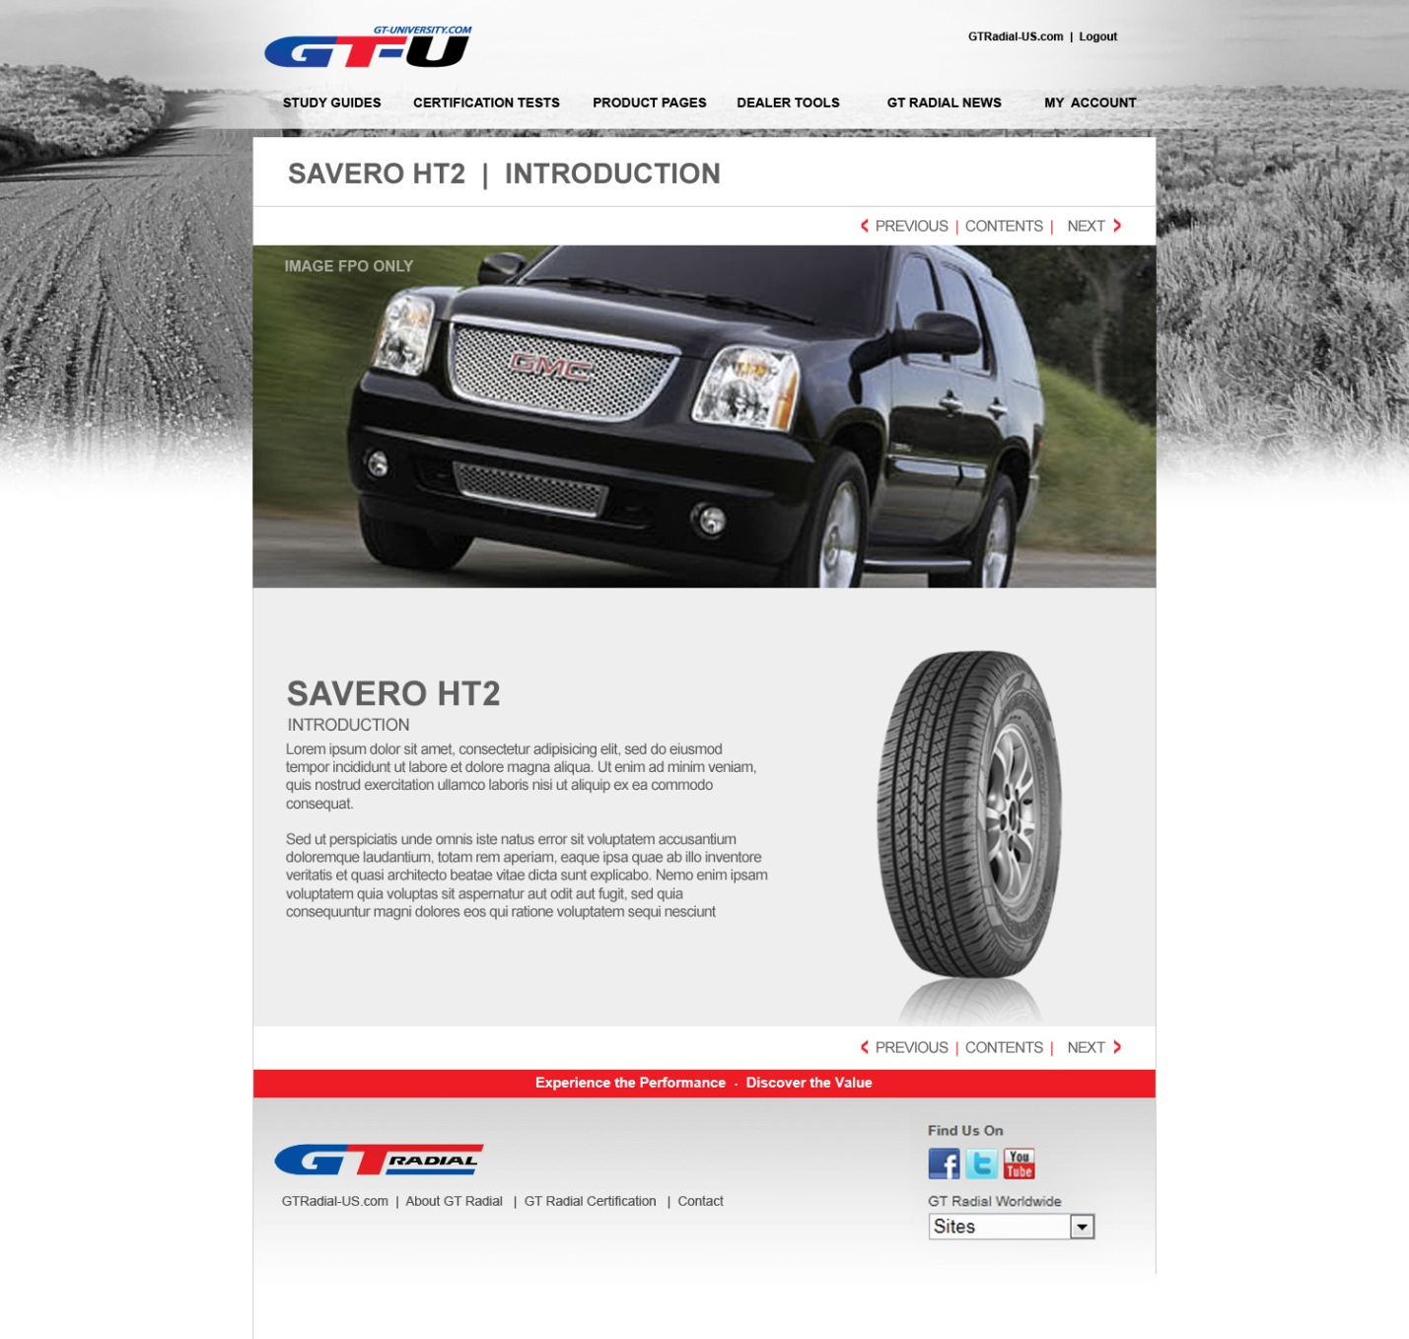

Certification Testing ) Not Done

  - Certifications tests (AKA Certifications), such as SAVERO LINE shown below, are collections of Test Modules.
  - Test Modules are created in the admin application
  - Test Modules are essentially dual language stand-alone tests – modeled after the tests on ToyoTraining.ca
- They are for one subject
- They do not have multiple chapters
- They allow for two languages. (FYI, more languages are likely be added in later upgrades)
- In the user’s language, they display the appropriate question and multiple choice answers.
- The Test Module is passed or failed. The criteria for passing is set within the admin app – just like on ToyoTraining.ca
  - Test Modules are grouped in to Certifications in the admin app.
  - When a user chooses a Certification, through the Certification Tests menu, the window splits (see designs provided) to show the Certification Test home page on the bottom screen
  - The Certification Test home page shows the status for all the Test Modules grouped together by that certification. Note that Test Modules can appear in more than one Certification.

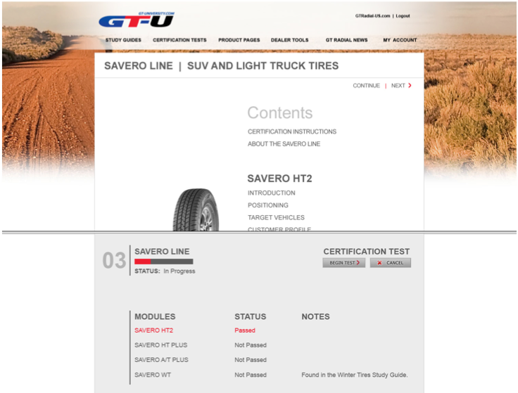

  - When a user completes a certification test, a report page tells them which tests they passed, and “tests not passed”
  - When a user passes all Test Modules in that Certification = Certification Complete
  - The first Certification Completion is recorded for each certification for each user.
  - That way, we can search for that information in the reports section of the admin application
  - If a new test is added to that certification later (in the admin app) the user will have completed a first certification, and that original date is recorded – but now the certification progress will show they still have Test Modules to pass
  - Pressing “begin test” will cycle the user through all their incomplete Test Modules for that certification.
  - After their first certification, and a new test module is added, they are not currently certified, but the site recorded that they once were.
  - When they pass the added test, they are again fully certified.
  - The last full certification date is also recorded for each user and each certification
  - Passing all tests = Full Certification
    - Full Certification shows on the Registered User home page view – see edit to example picture
    - First Full Certification date is recorded
    - Last Full Certification date is recorded.
    - Full Certification will generate an email to the user (managed in the admin app)
    - Full Certification will generate an email to the admins listed in the admin app
  - Downloadable PDF Certificates for test certifications and full certifications. Managed within test and certification sections.
  - Congratulations email for test and full certification. Managed under system emails tab.
- User Account Controls to update their basic contact information.
  - Consumer users cannot change their user type.

Admin Backend:

Login Dialog
- Remember me checkbox. This reacts different for an admin: When checked – and username and password are executed correctly -- next time it skips this page. Remembered admins should go straight to the register admin home.
- Tab key needs to move from field to field within dialog
- Enter key works to accept password
- When links or menus are touched or clicked, they words turn Red
Links
- Links at top all point away from admin site – to public site pages.
Masthead
- The GT-U logo is still pending.
- The white gradient graphic, and dimensions, are from GT-Radial-us.com

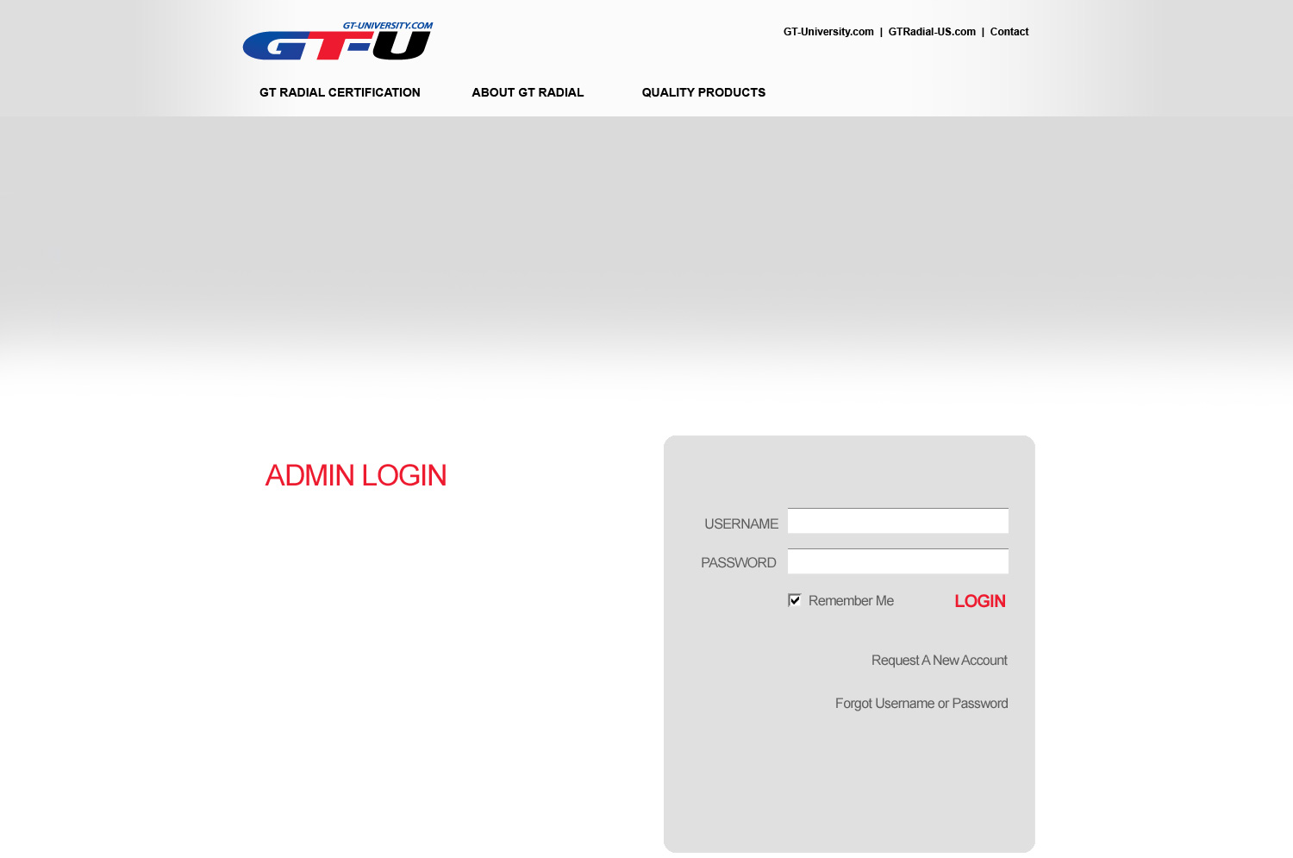

- Dashboard upon login

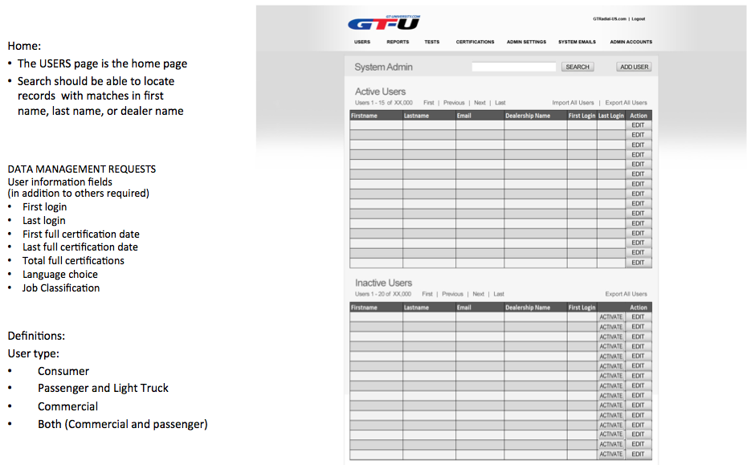
- User Management:
  - Approved/Unapproved status management
  - Search functionality to quickly find and edit user
  - Sorting as described above.
  - Export Functionality of all user information. (All or will export only the users shown after sorting is applied)

- Test Mangement:

How the application is structured
- Consumers will not take tests
- Only Passenger and Light Truck, and Commercial users will take tests
- User Types who will certify, include:
  - Passenger and Light Truck Dealer
  - Commercial Dealer
  - Dealer All
- All Certifications Complete = Full Certification = Gift Event
How Certifications Work:
- Tests are grouped into Certifications in the Admin app

Certification Test 1
Certification Test 2
Certification Test 3
Test ModuleA
Test ModuleB
Test ModuleC
Test ModuleD
Test ModuleR
Test ModuleF
Test ModuleA
Test ModuleY
Test ModuleZ

  - Tests (add, edit, delete) The ability to manage unlimited tests and unlimited questions per test will be included.
  - Test Questions (multi-language support)
  - Certificates in multiple languages
  - Search functionality will be included to quickly find and edit tests.
  - Assignment of test type (4 user types: Consumer, Passenger and Light Truck Dealer, Commercial Dealer, Dealer (All)

Creating Test Modules:

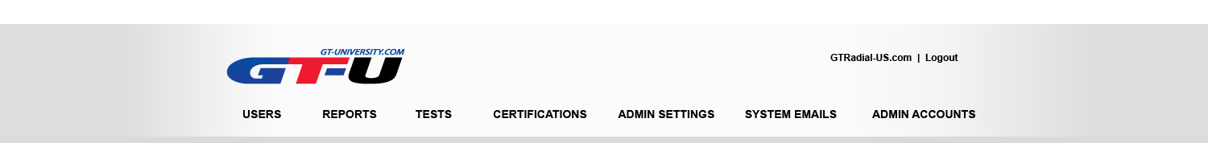
•Test Modules are created under the TESTS tab
•Test Modules need to be created first (prior to grouping into Certification Tests)
–Add test button will open dialog
–The new test button has the test name. Each test will have grading criteria and notes that can be sent for each grade to users and/or admins.
–Users only have to pass a subject test once.

Deleting
- Tests can be deleted
- Tests can be here – but not assigned to any certification
- Categories can be alpha or date sorted.

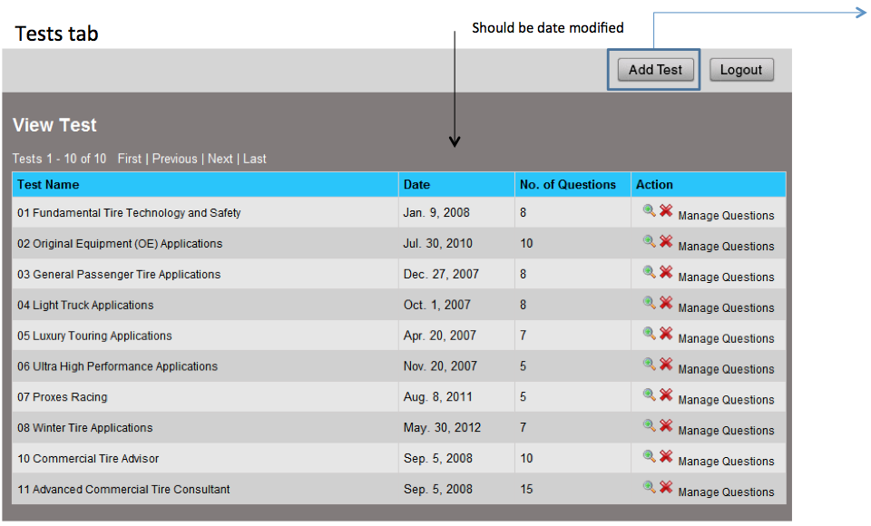
Test names will be for individual products or courses, such as:

Champiro UHP1
Champiro X
Saftey 101
Etc.

(Screenshot above for concept. Please follow style provided in new designs)
Adding a test

When you add a test, the admin has to enter:
- Test name
- Choice of who to send notification to for test passing (Test passing can generate unique notes – in addition to other system notes)
- No notifications for test failing.
- Text for notifications (user notes are multi-language). This is in addition to the other notifications found in the admin site. (Multilanguage user notes is not shown in these examples)

Certifications:

Certifications tab

- Tests are grouped together into Certifications under the Certifications Tab
- Certifications are organized into a table for viewing

Certification Name | Number of Tests | User Type | Date Created | Total users ever certified | Total users currently certified
 | Shows total tests grouped together for this certification | - Passenger and Light Truck Dealer  - Commercial Dealer  - Dealer All

- Add Certification button:
  - A certification dialog appears
  - Certification name
  - User Type menu (passenger, or commercial)
  - Add test button to add a test to this certification
  - A dialog with a menu of all tests appears
  - Options for messaging upon completion of certification – just like messaging for completion of test.
Note: We want to be able to sent auto notes for each test, certification, and full certification The text for tests and certifications should be stored with that test or certification. The text for full certification should be found under the System Emails tab in the admin app
  - OK adds it to a table of tests for that certification
- An admin can add another Module Test to the certification at any time.
- First time a user passes a certification, that date is recorded.
- Adding a Module Test to an existing certification, will move a user from certified, to not certified – but the date they first certified remains recorded.
- The site will also record the last date a user was fully certified. If they have certified once – the two dates are the same. But if they have re-certified each time a new product is added – then we can see when the first time and last time they passed this certification

Reports:

Reports tab

- Reports are organized into a table for viewing, editing, and running.
Report Name | Date Created | Report Type | Action
 |  | User  Test  Certification  Dealer  Post user survey | Run, Edit, delete

- Choice to create new report
  - Report Name
  - Report Type Menu (user, test, certification, dealer, post user survey)

- User Reports:
  - Username criteria
  - First Login Date Range Criteria
  - Last login date range criteria
  - Job Classification
  - Button to save report
  - When run, Report returns users (separated by a line) who meet the criteria – and shows
    - Certifications – if ever certified, and Status: “Up to Date” or “Additional Tests Required”
    - Tests Passed
    - First login date
    - Last login date

- Test Report
  - Filter by test name (menu of existing tests)
  - Date range for completion
  - Report returns users who have passed that test

- Certification Report
  - Filter by Certification name (menu of existing Certifications – with choice for Full Certification)
  - Choice to show all users who have ever passed
  - Date range for completion of latest certificaiton
  - Report returns users meet criteria with …
    - Test Modules Passed
    - Date of first certification
    - Date of last certification
    - Status: “Up to Date” or “Additional Tests Required”

- Dealer Report
  - Criteria:
    - Dealer name
    - Store number
    - State
    - Zip
    - Telephone Area Code
  - Report returns users (separated by a line) who meet the criteria, and shows:
    - Certifications – if ever certified, and Status: “Up to Date” or “Additional Tests Required”
    - Tests Passed
    - First login date
    - Last login date
- Post User Survey Report
  - Criteria
    - Certification type
    - Date range of last date certified
    - This report just returns back survey responses for each user who meets the criteria, separated by a line.
- Report Actions
When a report is run – the results page has choices at the top:
  - Export Results – Makes Data Table
  - Export Email Addresses -- allows for export of email addresses in simple text file, separated by a semicolon (in case admin wants to send from another system).
  - Email to users
    - Email window opens, with email addresses from report, ready to type and send
    - Email uses html template file for formatting
    - Record of emails sent stored in data table
    - Replies sent to Training Coordinator

- Management of system settings:

Admin Settings

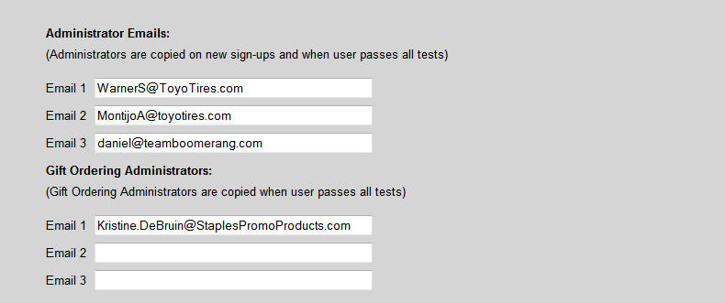

  - Email addresses for system notifications
  - Global Pass and Fail grades for all tests
  - Approved Dealer List
  - Job Classification List
  - Post user survey
    - How it works:
      - User gets an email after they complete a certification with link to survey
      - The survey records which certification they passed
      - Questions are added to the survey in the Admin Settings section of the admin app – but the questions are added just like a test
      - Users who get survey links will be returned to the site (they do not need to sign in
      - Survey does not ask for name at any time
      - Survey responses included multiple choice, or text responses
      - Surveys can be filtered by date, certification type.

- System Emails) Done
  - The System Emails section in the admin should include categories for
    - Consumer Emails
    - Passenger and Light Truck Dealer Emails
    - Commercial Dealer Emails
    - Admin Emails.

Consumer Emails
- Welcome email

Passenger and Light Truck Dealer Emails
- New User: Activation pending
- Welcome – (Activation approved)
- Full Certification note – with link to post user survey
- Inactive Account notice (for users trying to log in who are deactivated)

Commercial Dealer Emails
- New User: Activation pending
- Welcome – (Activation approved)
- Full Certification note – with link to post user survey
- Inactive Account notice (for users trying to log in who are deactivated)

Admin Emails:
- New consumer has enrolled notice to admins
- New Professional user has enrolled notice (dealer types)
- Full Certification Gift Email (to admins and gift admins)

- Administrator Account Management (Add/Edit/Delete)

- Responsive Design for Tablet display Should have basic formatting to fit properly on an ipad (public, testing and admin) See sample mockup below and PSD files for specific suggested layouts. Site framing for tablets should be identical to the framing for www.gtradial-us.com

